Suggested Weekly Work for First Class – 30/3/’20- 3/4/’20
A note from teachers:
We hope everyone in First Class is okay, we miss you all very much. We know this is a difficult time for everyone. Do your best with this work but please do not worry if you are unable to access the websites. Try your best, keep safe and keep smiling.
Ms. Boyle & Mr. Doody
English
Reading:
Shared Reading: Read a book with your child.
Discuss the story with your child. Ask them to retell the story in their own words and identify their favourite part.
Read an article on Pet Care of a Dog:

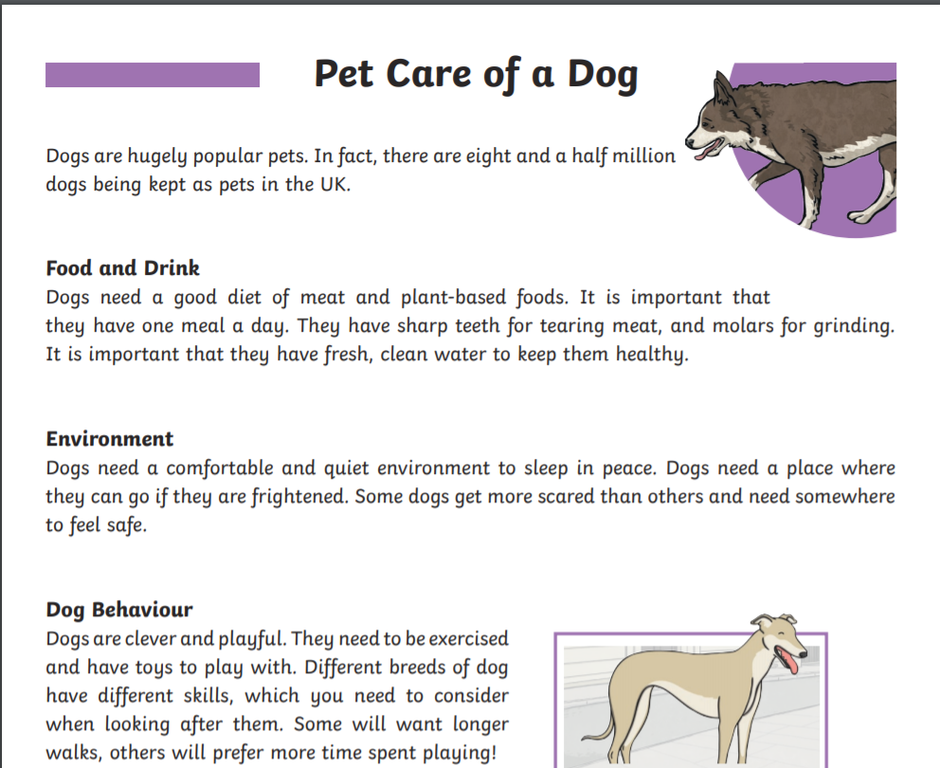

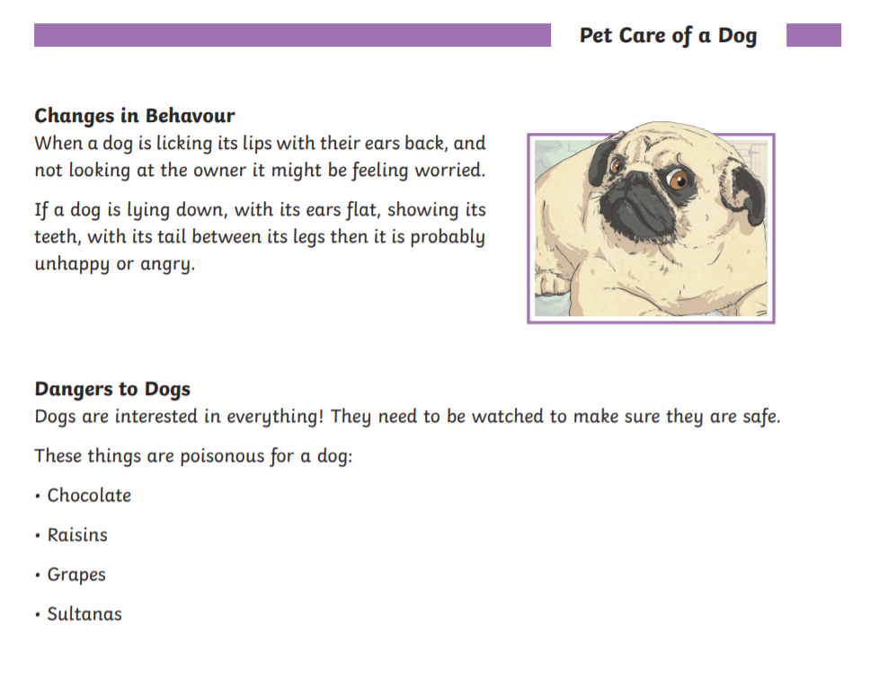___________________________________________________________________________

Questions: (Answer Orally)
- Do you think dogs like being a pet?
- Is it safe to rub a dog you see on the street? Why not?
- How can you tell if a dog is sad ?
- What type of things can scare a dog?
- Is it kind to walk dogs? Why?

Spellings
New vocabulary/spellings into sentences-orally.
Week 23rd March
lake | make | bake | late | face
take | fake | take | hate | lace

Game: 4 in a Row
To play, take turns reading the words and colouring them in/ ticking them. Whoever gets four in a row first, wins!

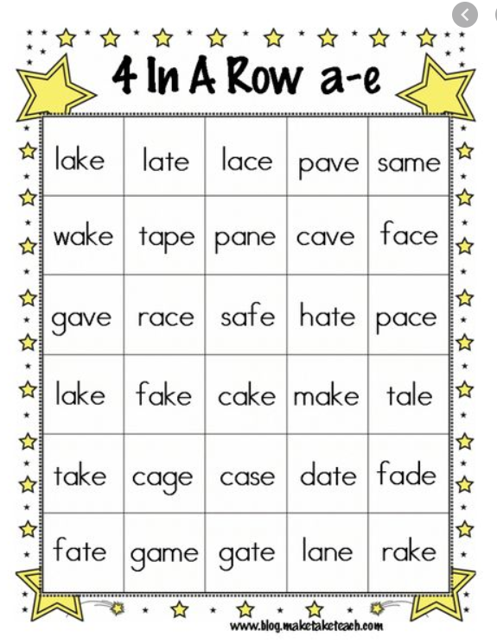

This is an example:

This is an example:
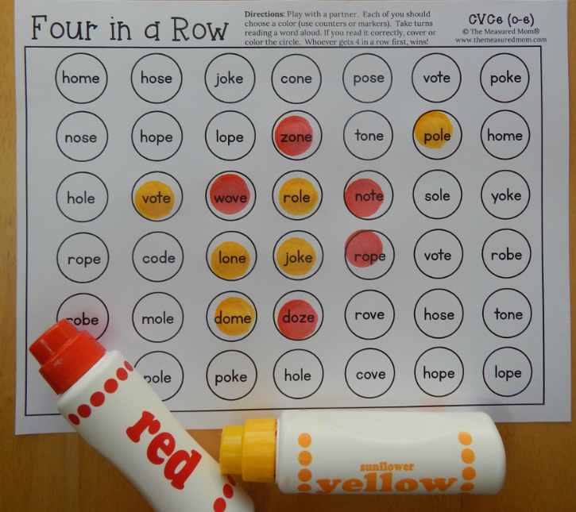

Writing:
- Answer the following questions on ‘Pet Care of a Dog’. Please use full sentences in your answers. Remember capital letters and full stops!

- How many dogs are kept as pets in the U.K?
- How many meals should a dog have each day?
- What types of food do dogs need to eat?
- Why is it important to walk dogs?
- What types of food are dangerous for dogs?
- Do you think dogs are clever animals? Why?

Handwriting – To access folens online:
https://www.folensonline.ie/registration/?r=t.
Register as a teacher and use the code Prim20 for Roll Number.

Search: Write Here Book C or click the link below
Focus on capital letters (U and S , N and M) – P.24/25
https://www.folensonline.ie/home/library/programmes/writehere-bookc/ebook/
Grammar:
Punctuation (Full stops, questions marks and exclamation marks)
Online Grammar Activity: Pets
https://content.folensonline.ie/programmes/Starlight/1st_class/resources/activities/SL_01_ACT_Core_03_008/index.html

Phonics:
Word Families : est, ump, ent
https://www.folensonline.ie/home/library/programmes/soundsinaction-a1stclass/ebook/

BRAIN GAME:
Look at the words on page 27 for 1 minute. Cover. How many words can you remember? Can you write them down?

Maths:
- Count up in 2’s, 5’s and 10’s

- Use hundred square to check if you are correct!

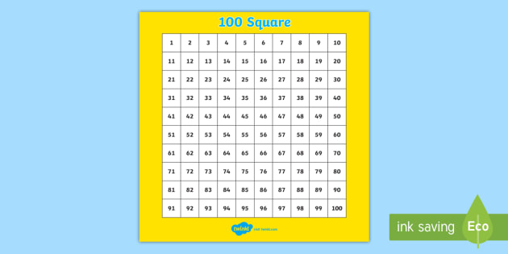

Addition warm up game :
https://content.folensonline.ie/programmes/PlanetMaths/PM1/resources/activitya/pm_1c_010/index.html

Sums: 10+6= 12+8= 15+4= 25+4= 33+6=

28+2= 14+5= 17+6= 34+6= 42+7=

Gaeilge:
Duo lingo Gaeilge – a fun way to learn Irish online https://www.duolingo.com/learn

An Cháisc – Easter
Fóclóir/Vocabulary:

An Cháisc - Easter | Seacláid - chocolate | Ciseán cásca – Easter basket
Ubh chásca – Easter egg | An t-Earrach - Spring | Lus an chromchinn - Daffodil
Sicín – chicken | Milseáin - Sweets | Coinín - rabbit

SPHE:
Myself
Keep a gratitude journal, listing 3 things you are thankful for each day. Please draw pictures in your journal.
SESE:
Take a nature walk look at the spring flowers talk about your favourite one/ draw a picture of it

PE:
Practice Mindfulness (Cosmic Kids yoga)
https://www.youtube.com/watch?v=ho9uttOZdOQ

Youtube [Pick some activities on the following]:
- Go Noodle
- Just Dance

Religion:
Prayers – revise Sign of Cross, Hail Mary and Our Father
To help teachers, students and parents during this difficult time Grow in Love granting free access to Grow In Love AND Soul seekers online series. Simply login on the www.growinlove.ie website with the following details:
Email: trial@growinlove.ie
Password: growinlove
Art: Get creative with Easter art. Have a go at this tutorial of ‘How to draw and Easter Bunny’. https://easydrawingguides.com/how-to-draw-an-easter-bunny/

Ongoing work:
Start a project on a topic/topics that interests your child. The children can add a page each day. It could be about their favourite book, person, film, hobby, football team, Disney character or a country. They could draw, paint cut out pictures to add into their book each day and they can present their masterpiece when school starts back.

We will be in touch with you again after the Easter holidays. Have a happy Easter and enjoy it as best you can.
Ms. Boyle & Mr. Doody.

