Old and Strange instruments
Junior and Senior Infants

We are going to look at 4 very very old instruments
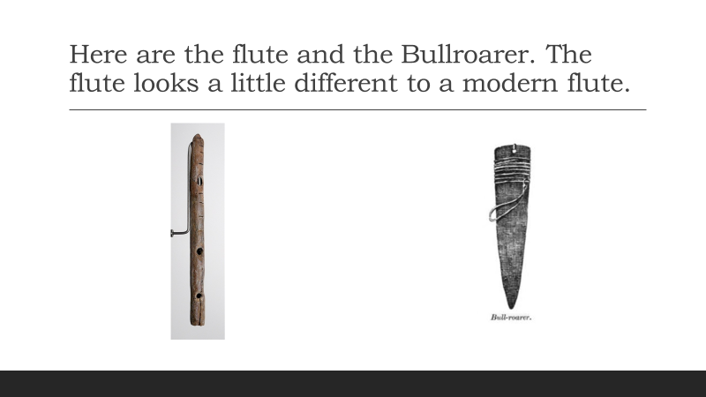
Have a look and see how the Bullroarer makes its sound. It’s sound can travel for miles and miles
https://youtu.be/1tvreQ3hTvA

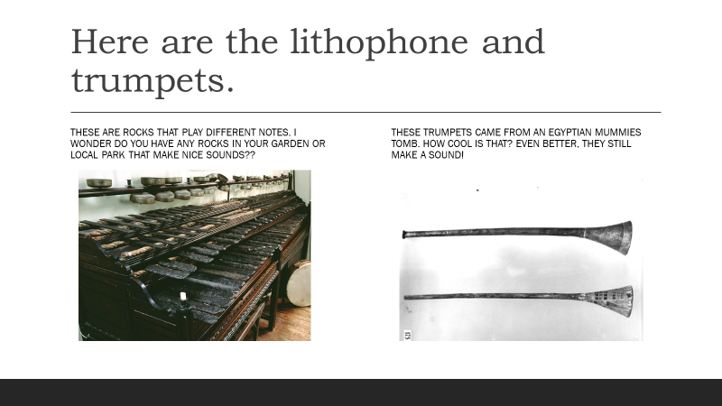
Have a listen to the sound of one of the trumpets. It is over 3000 years old!!!!
https://youtu.be/HO3P5jkQmgU
- Imagine. This trumpet came from the tomb of a very famous Egyptian mummy. His name was King Tut.
- It is rumoured that the sound of the trumpet can call people to war!!!
- I hope not.
- Now to the unusual. Do you like to play with marbles?
- This instrument was invented in 2016, so its very new.
- It holds 2000 marbles!!!!
- Do you like the sound?
- I think it looks very tricky.

- https://youtu.be/IvUU8joBb1Q
- Last but not least, my favourite. I hope you are not feeling hungry after watching this.

- Did your family ever tell you not to play with food?
- No one told these musicians that!!
- For this week do you think you might be able to make an instrument out of some fruit or veg?
- Hope you enjoyed our class this week and I look forward to sharing next weeks class with you.
https://youtu.be/xM1EjIDLMLY

