Suggested Weekly Work for First Class – 2/6/’20 - 5/6/’20
A note from teachers:
We hope everyone in First Class had a great Bank Holiday weekend.. We are so thrilled to see you all working so hard and trying your best to complete your schoolwork during these difficult times so please keep up the excellent work! Parents, you are doing a tremendous job at being teachers! Thank you for listening to reading, writing out worksheets and providing encouragement for your son/daughter. You are making a real difference. Also, we would like to say thank you for all your feedback through emails and telephone calls. Keep safe, keep washing your hands and keep smiling.
Ms. Boyle & Mr. Doody
English:
Reading: ‘Lilly and the Tooth Fairy’
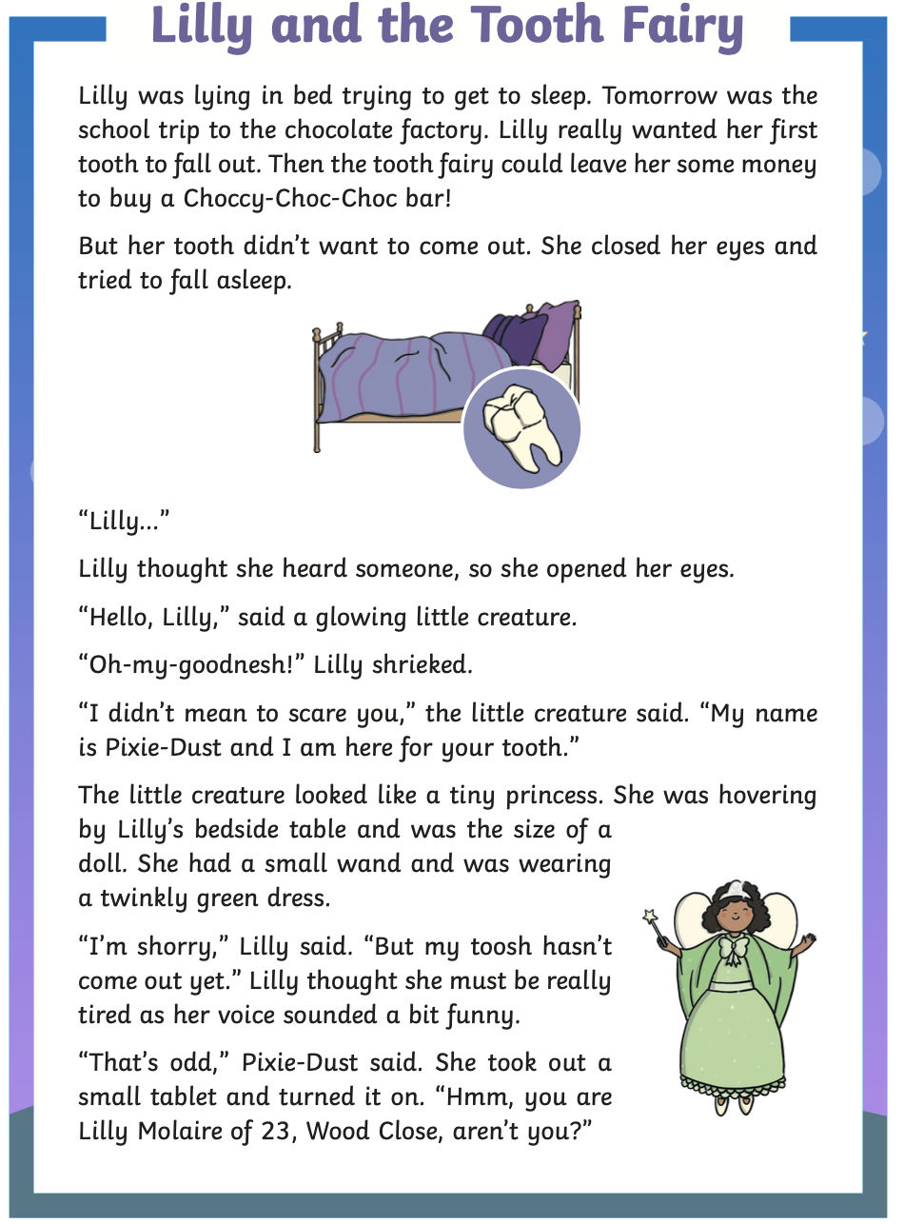
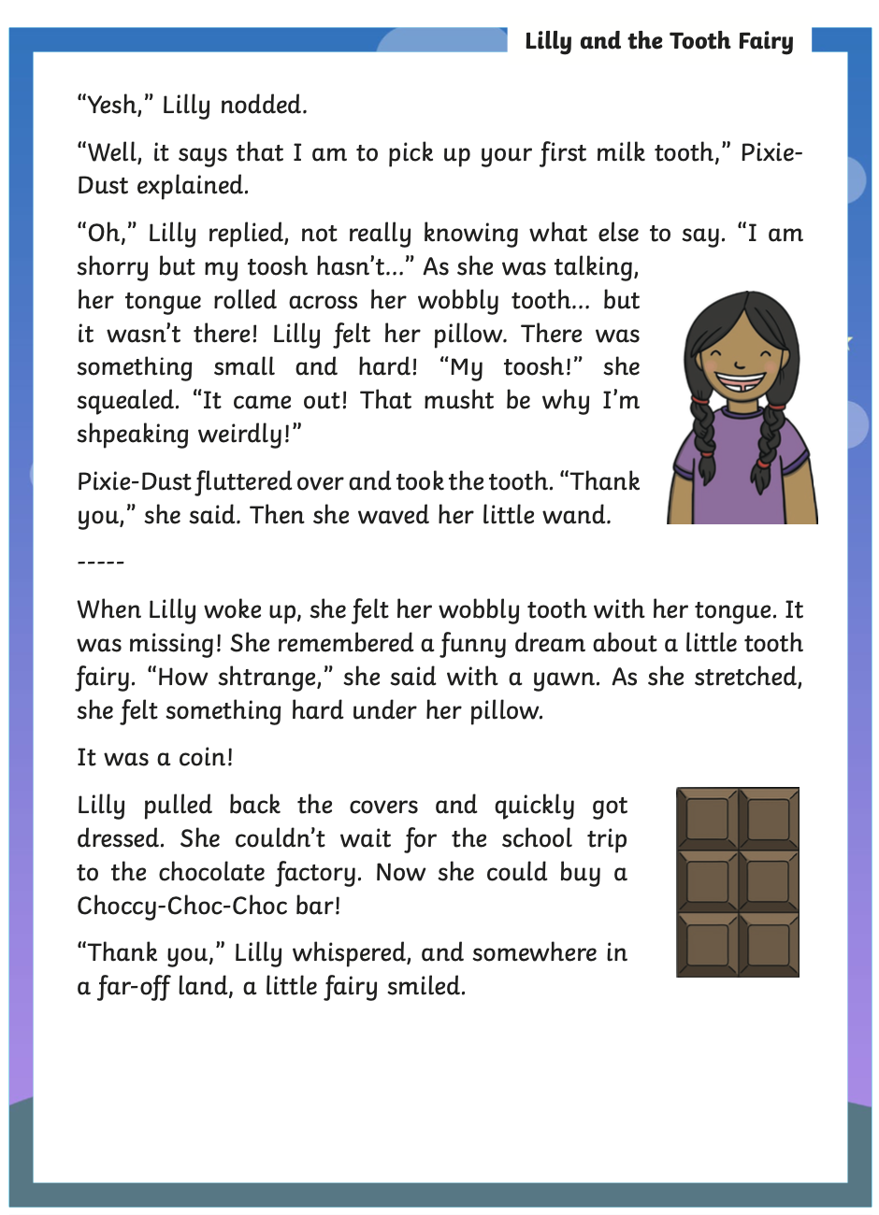

Questions: Please write the answers to these questions on a sheet. Remember to write full sentences using capital letters at the beginning and a full stop at the end. We love to see tall letters touching the lines: b d f h k l t.

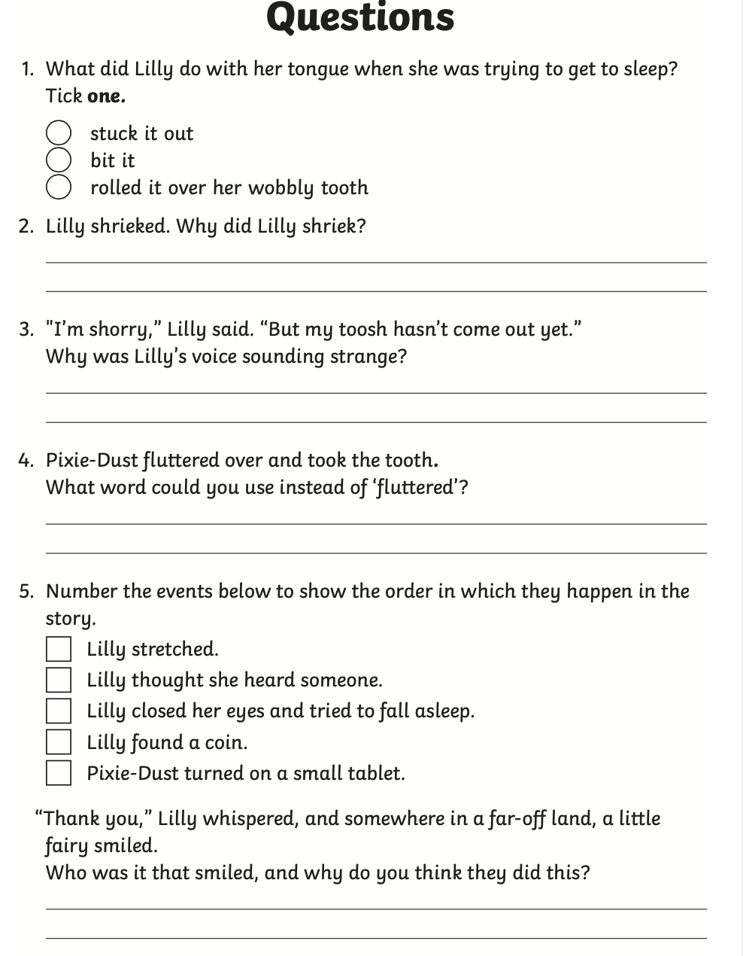
6. Write a description of a time when one of your teeth fell out and you came across
the Tooth Fairy.

_________________________________________________________________________________________
_________________________________________________________________________________________
_________________________________________________________________________________________
_________________________________________________________________________________________

Extended Reading: 60 Second Reads
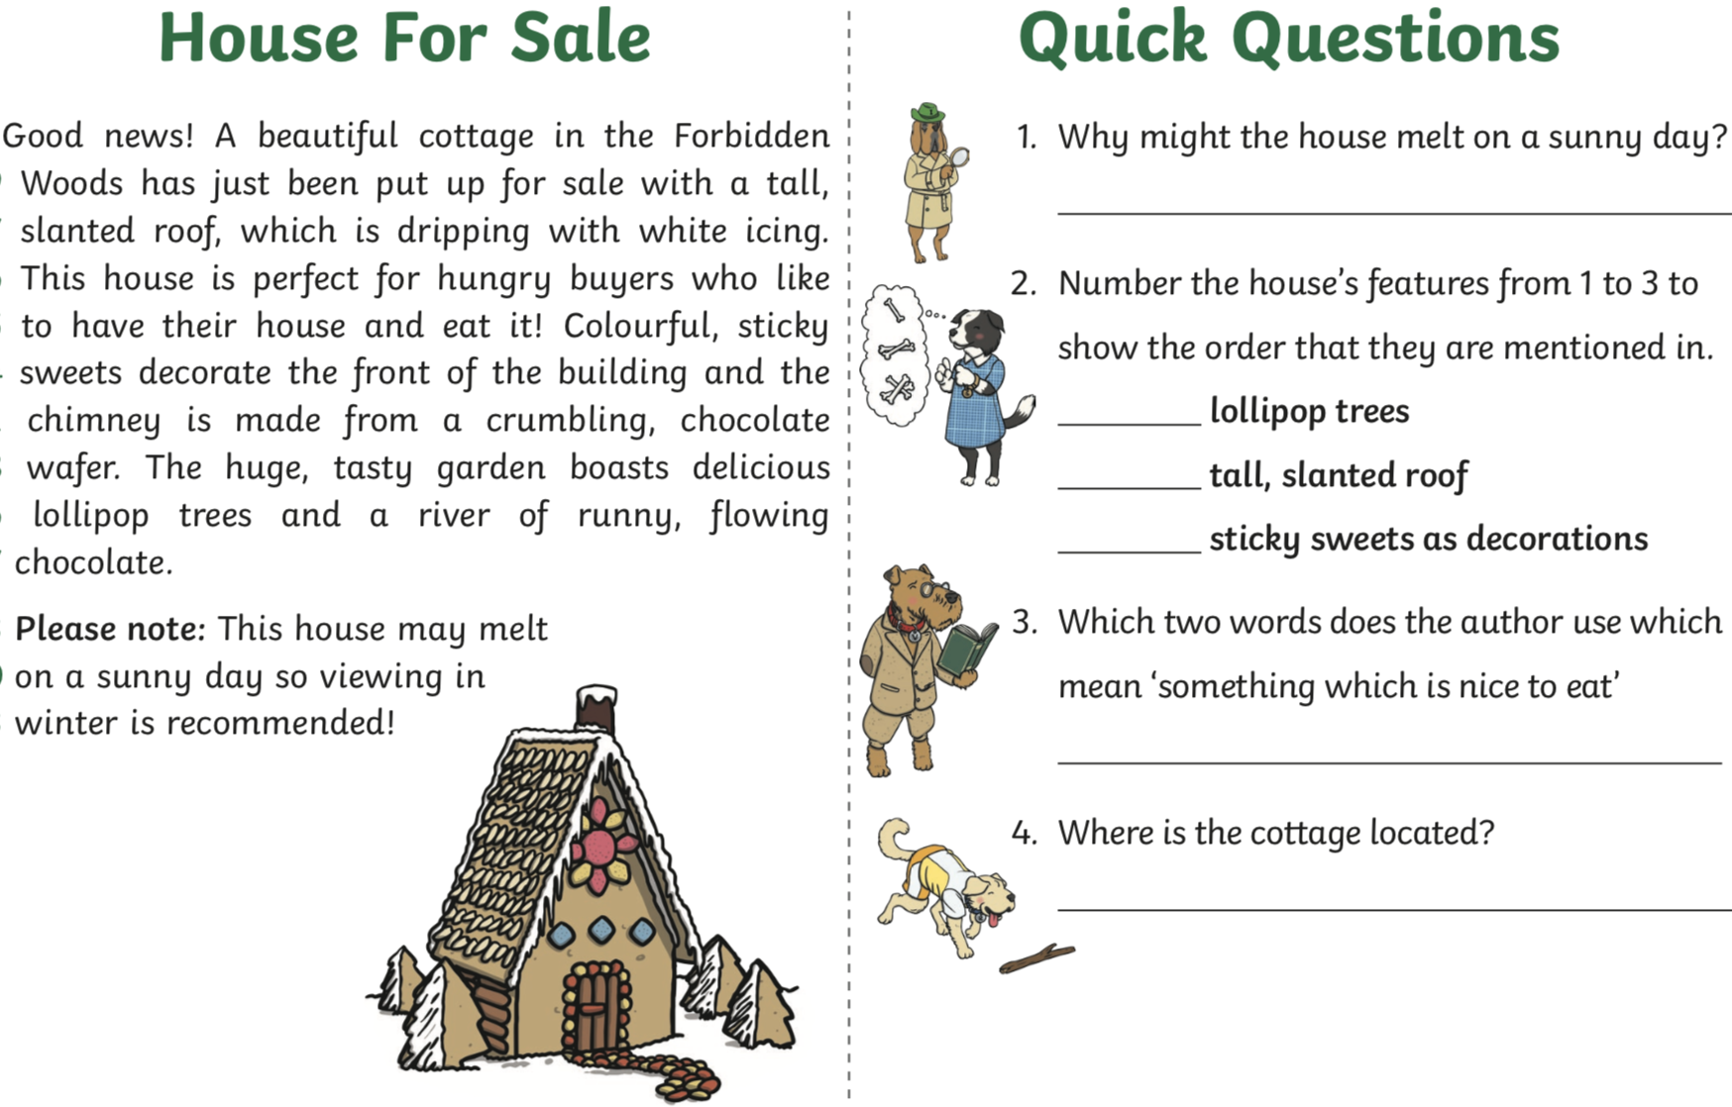

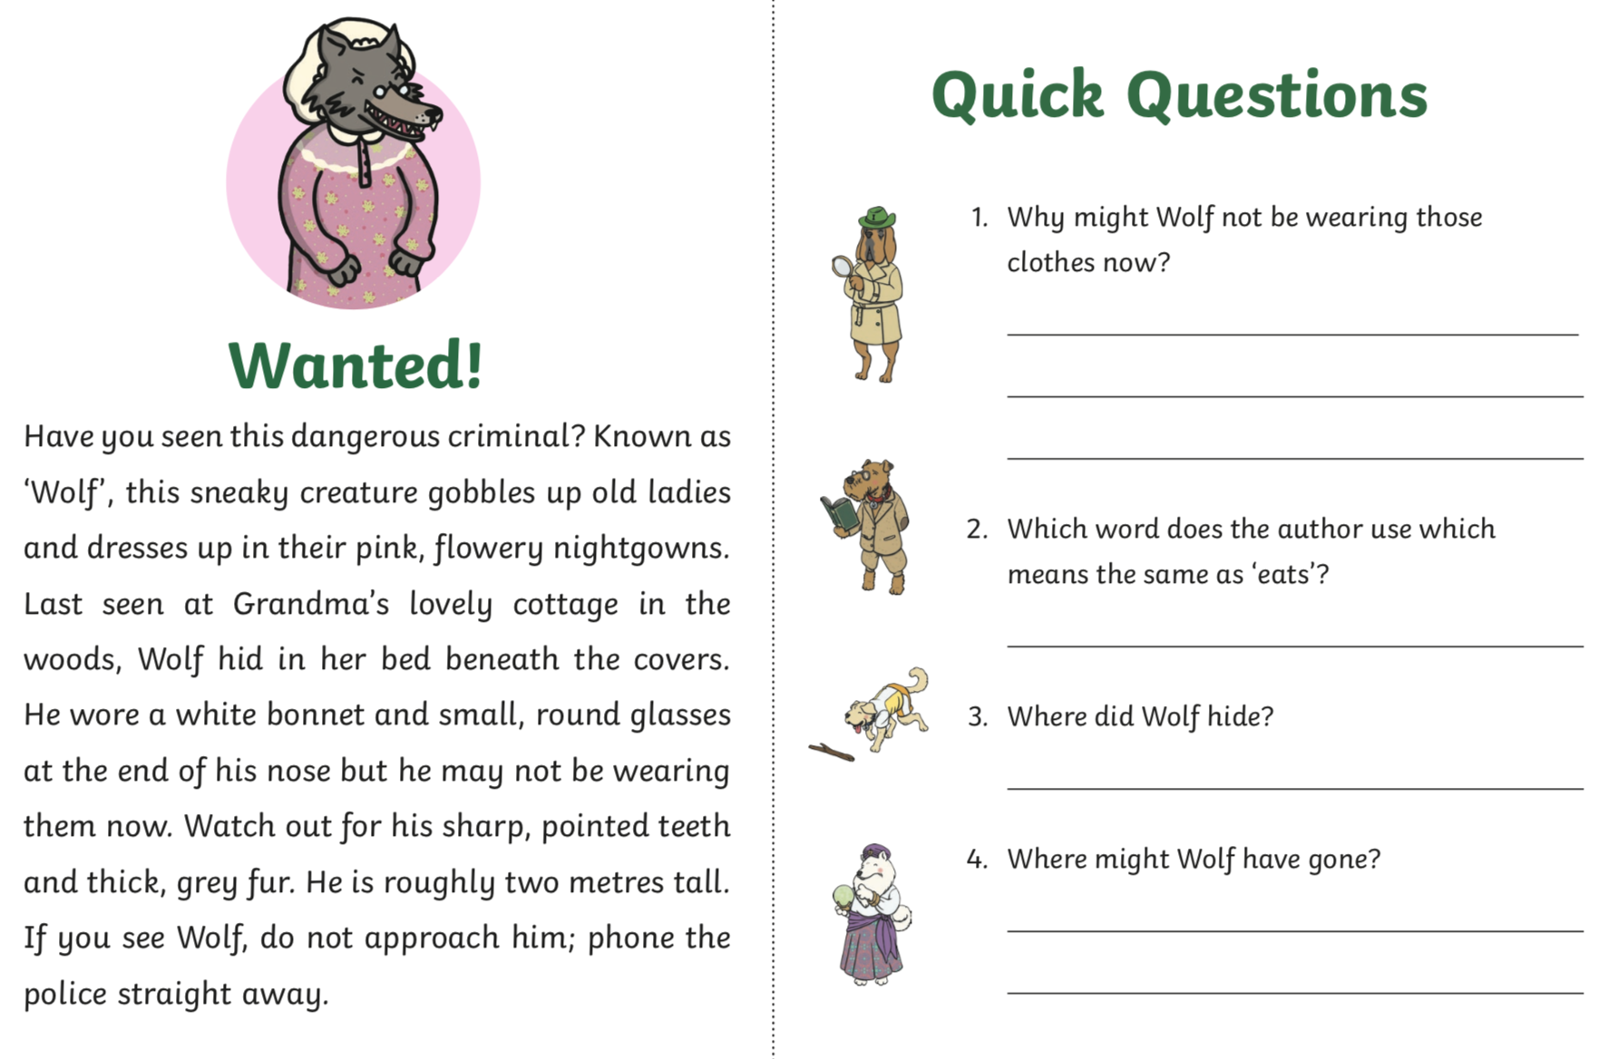

Vocabulary from the texts
Please discuss the meaning of these words:
forbidden | beneath | roughly
bonnet | wafer | dangerous

Extra Reading -Please click the link : https://www.oxfordowl.co.uk/for-home/find-a-book/library-page/ . Click join us at the top right hand corner. Enter an email address and password. Once you have verified your email you will have access to lots of beautiful e -books.
Spellings
Please discuss these spelling words and put into sentences-orally.
Word families: nk words.
bank | sink | rink | wink
think | pink | bunk | shrunk
tank | skunk | link | ink

Please practice reading and writing these spelling on a sheet. You can use this format:

bank | think | tank
bank
bank
bank

Vocabulary: Complete 80/80 of the game each day picking a new theme each day.
https://www.gamestolearnenglish.com/fast-vocab/
Note: If link shortcuts do not work by clicking on them directly, please copy and paste each link into your internet browser search bar.
Also please be aware that Folens online can be very slow if many users are logging on at the same time. If this is the case please try again at a different time. Thank you for your patience.

To access folens online:
https://www.folensonline.ie/registration/?r=t
Register as a teacher and use the code Prim20 for Roll Number.
Once you are logged in you access these links.

Handwriting On Folens online, search: All Write Now 1st Class or click the link below. Pg.’s 47 - 61. Focus on tall and small letters.
https://www.folensonline.ie/home/library/programmes/allwritenow-1stclass/ebook/
Grammar: Verbs
A verb is a word used to describe an action. For example to run, to jump, to read.
Activity A:
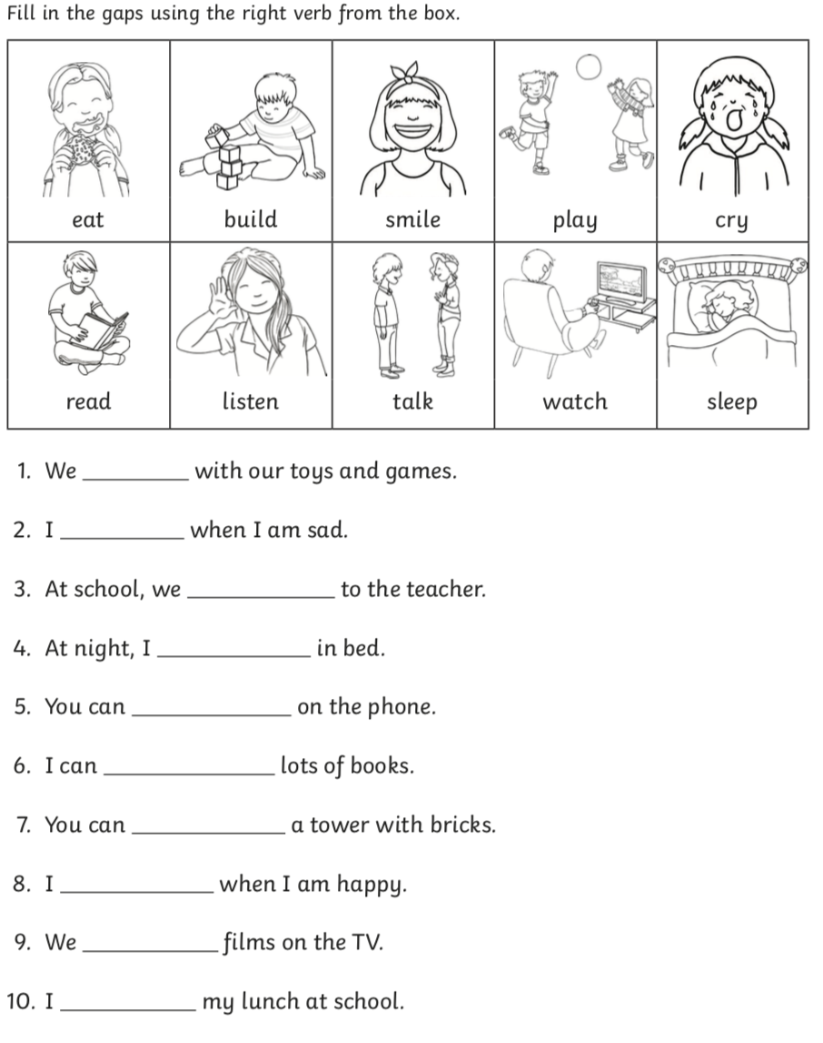
Activity B
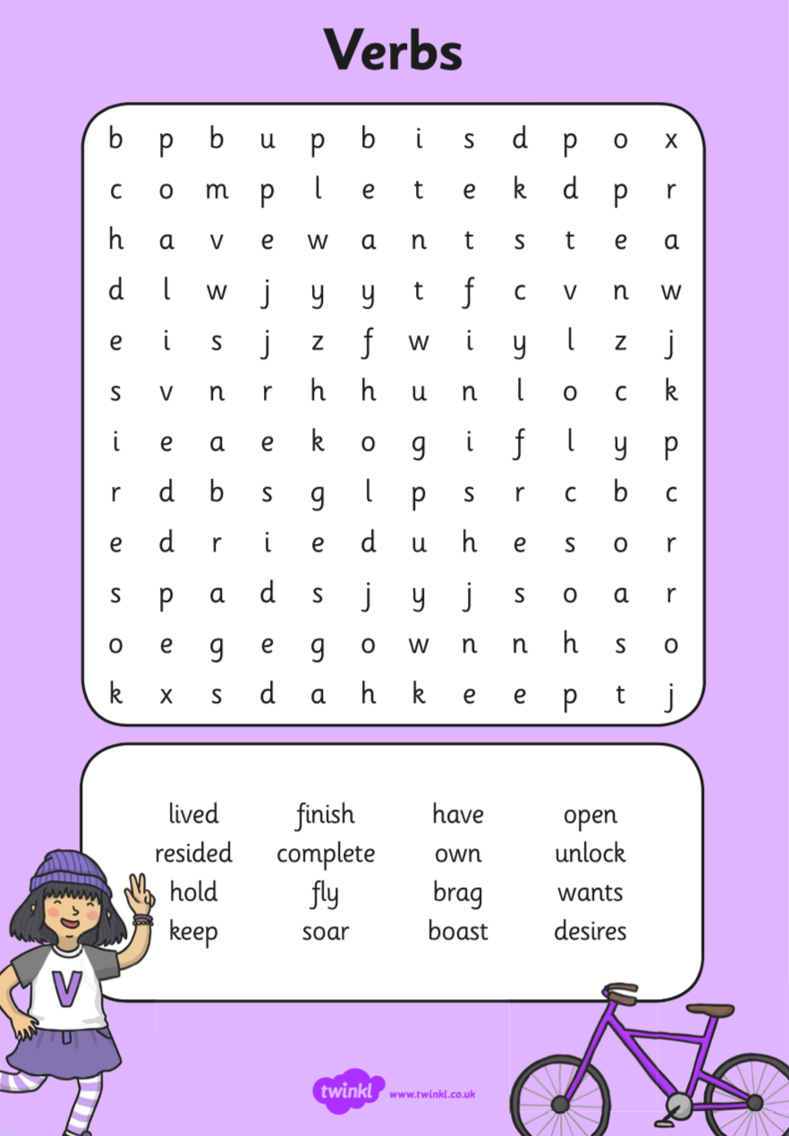

Activity C
Are these verbs? Click on the link.
https://content.folensonline.ie/programmes/Starlight/1st_class/resources/activities/SL_01_ACT_Comb_01_008/index.html

Smash the Robot Verbs Game – You must click on the verbs.
https://www.sheppardsoftware.com/grammar/verbs.htm

Maths:
Please practice these sums on a piece of paper. Remember we always add the units first
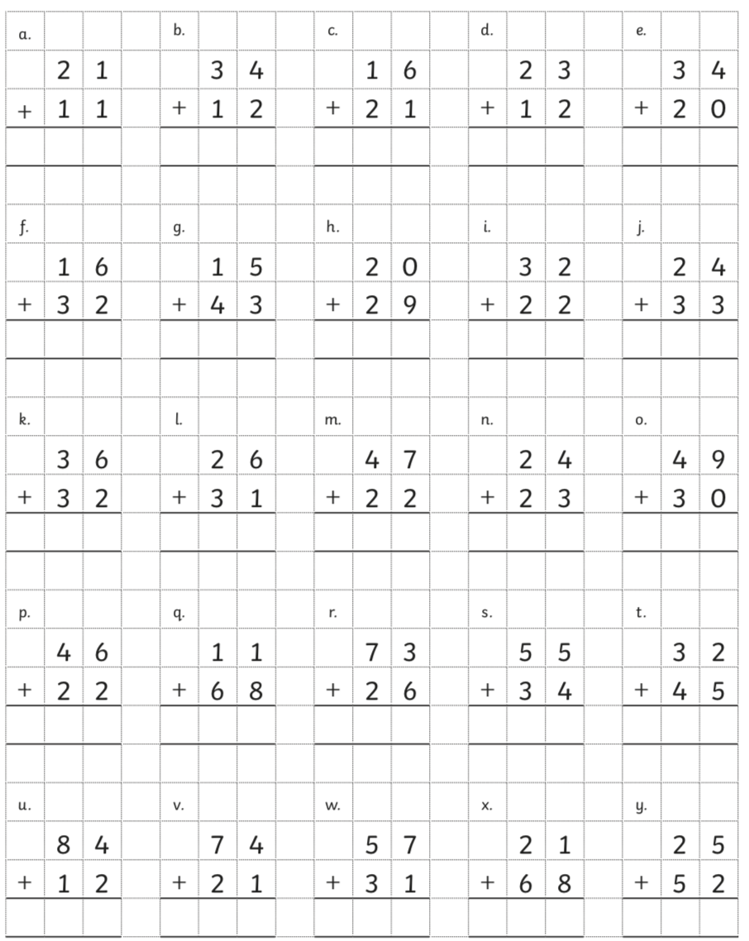
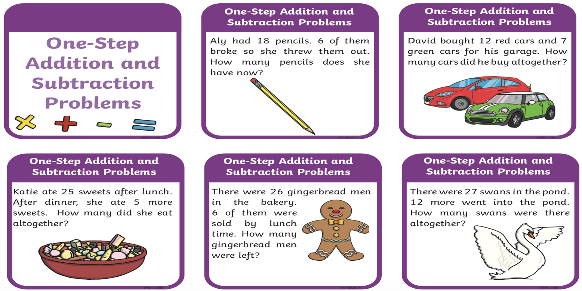
Volume:
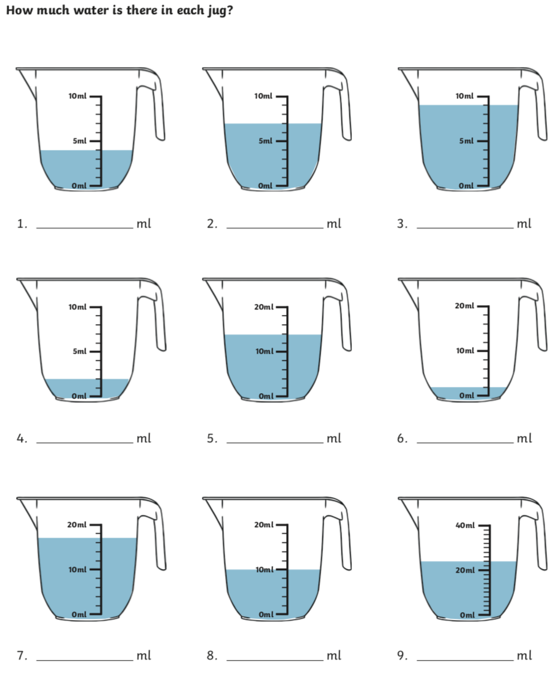
Find and name items around your home that are these 3D shapes below. See how many you can find. Let the 3D shape hunt begin!!!!!!!
 | 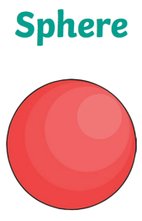 | 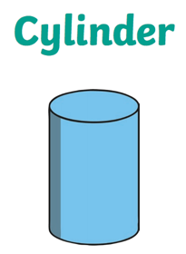 | 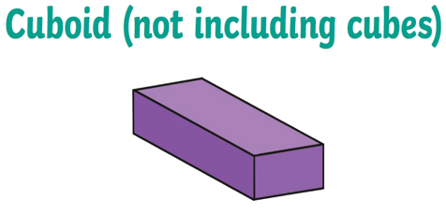
Gaeilge: An Aimsir
Duo lingo Gaeilge – a fun way to learn Irish online https://www.duolingo.com/learn
doracha - dark | tirim - dry | sioc - frost
geal - bright | fuar - cold | tuile - flood

Find the words for different types of weather in the word search. Say the word out loud when you find it.
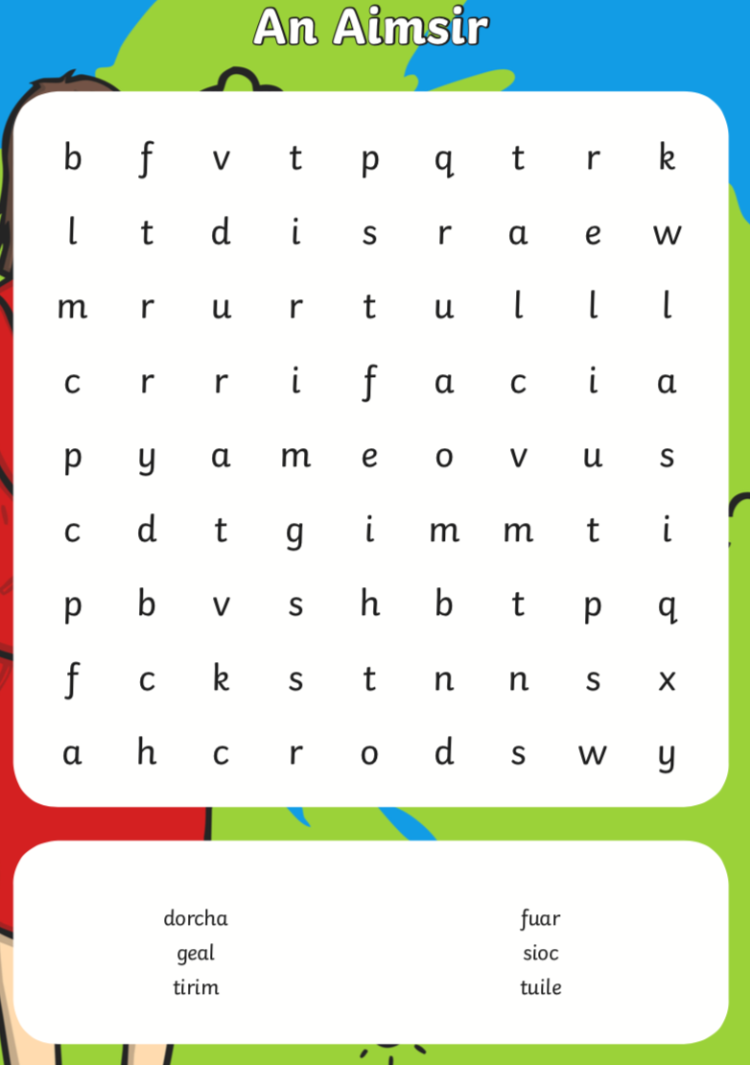

Music: Ms. Barry
What are we going to do this week? I have made a couple of short videos to show you how to read the music notes and then I have some pages for you to try out.
Try and use a pencil so you can rub it out if you make a mistake.
Lets get started.
Here are 3 very short videos of how to read the music lines and spaces.
https://youtu.be/Ej8U6XPkTyY
https://youtu.be/EsjqMP4YToo
https://youtu.be/bhG4B7LbQfQ
SESE:
Write the instructions on how to brush your teeth correctly!!!!!
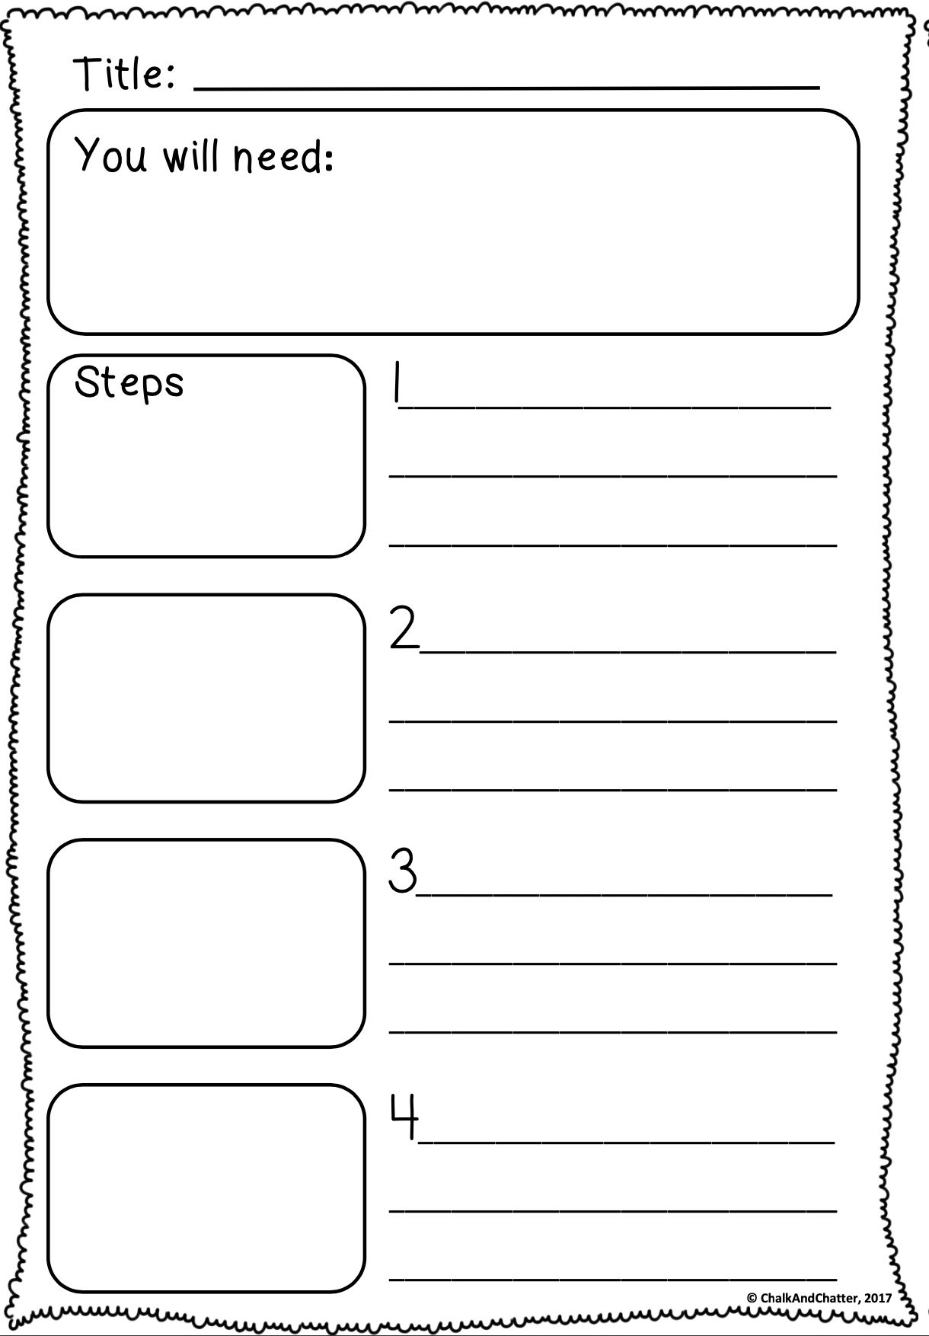
SPHE: My Kindness Diary
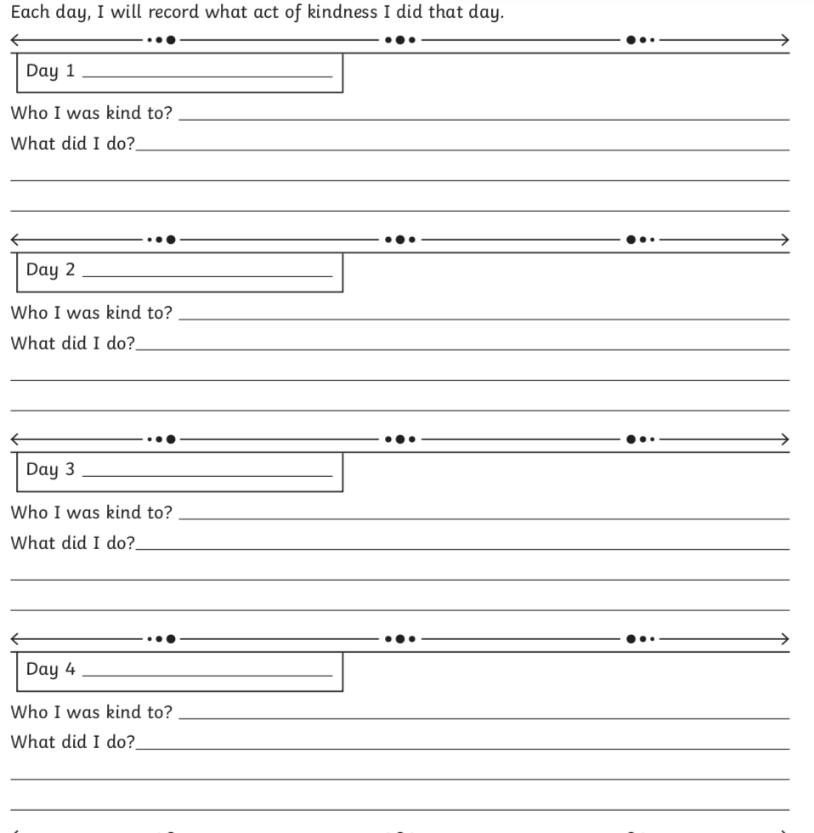
PE - Practice Mindfulness (Cosmic Kids yoga) https://www.youtube.com/watch?v=ho9uttOZdOQ
We want all the children in our classes to stay active. Every day we want you to complete the workout provided below. You can do it in your home and it will keep you healthy and active. You will complete the exercise for 30 seconds each with 20 seconds break between exercises. Repeat 2 times.
Tuesday | Wednesday | Thursday | Friday
Jog on the Spot  Press ups  High knees | Jog on the Spot  Lungs  Jumping Jacks | Jog on the Spot  Press ups  Sit ups | Jog on the Spot  Squats  Jumping Jacks
On Youtube, Joe Wicks is doing a new PE workout each day for children at home called P.E. with Joe. Follow the workouts on your TV, computer or tablet.
https://www.youtube.com/channel/UCAxW1XT0iEJo0TYlRfn6rYQ

This is another lovely link to many PE exercises and dances
https://www.weareteachers.com/virtual-pe-classes/

Also here is a link to improve your GAA skills.
https://learning.gaa.ie/gogamesskillchallenges

Religion:
To help teachers, students and parents during this difficult time Grow in Love granting free access to Grow In Love AND Soul seekers online series. Simply login on the www.growinlove.ie website with the following details:
Email: trial@growinlove.ie
Password: growinlove
‘Creation’ - https://app.growinlove.ie/en/user/lesson-resources/159

Art: Get creative with art at home. Have a go at this tutorial of a crab and a starfish!!!!
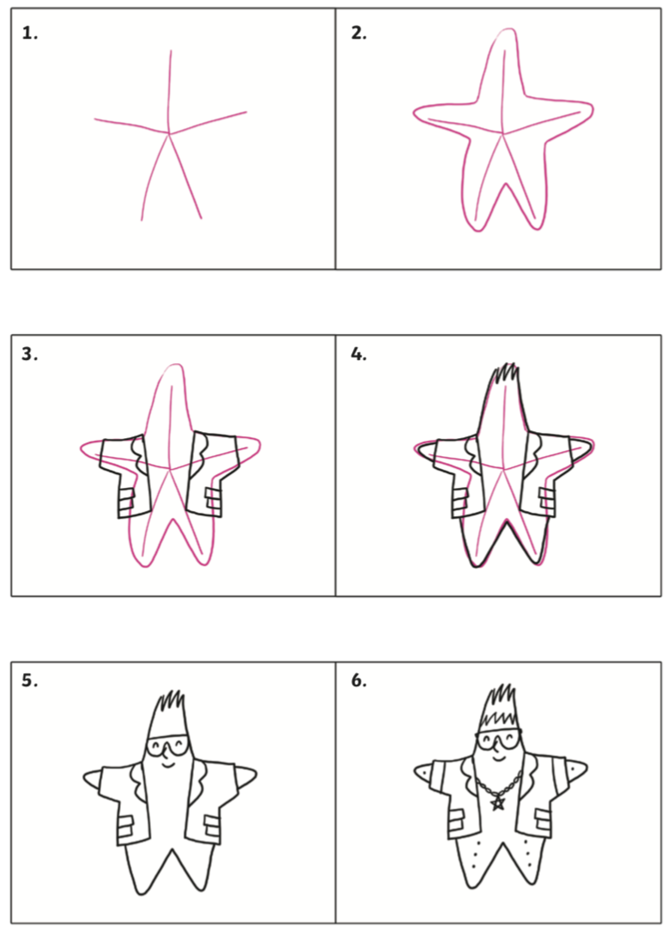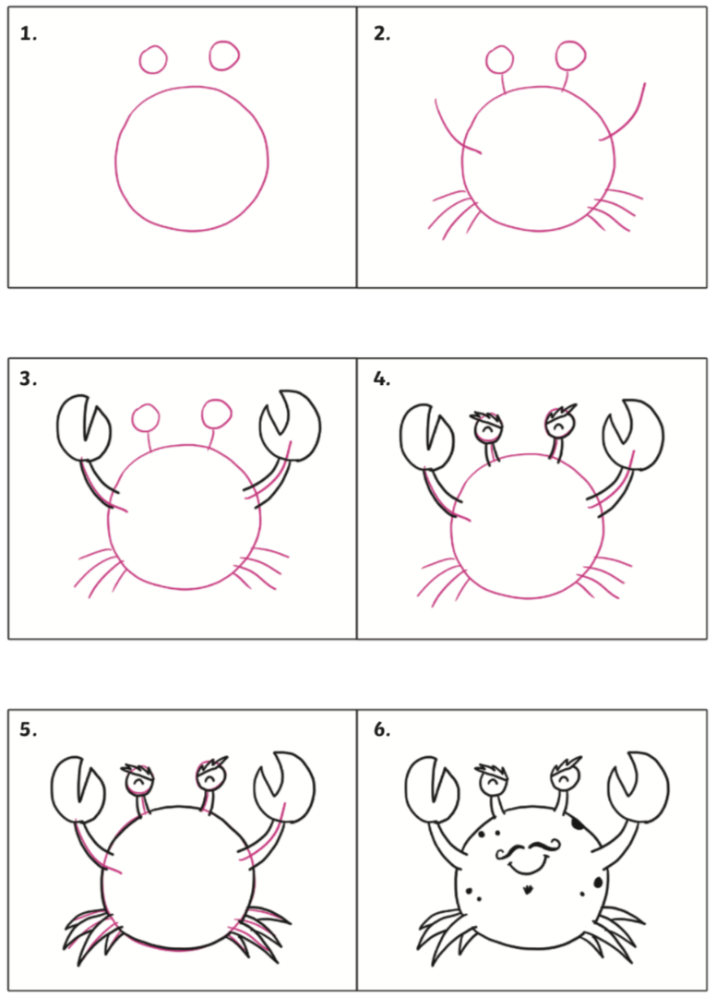
Our class email for feedback is: firstclassmarist@gmail.com
We welcome and appreciate all feedback. Thank you for your patience at this difficult time. We everyone is safe and enjoying the beautiful weather.
Ms Boyle & Mr Doody.

