Suggested Weekly Work for Second Class – 03/06/’20- 05/06/’20
A note from teacher:
Hi to all the girls in 2nd class.
I hope you all had a fabulous bank holiday weekend and enjoyed our beautiful weather. Remember to put on suncream! If we were in school you would have been off Monday and Tuesday this week – maybe your teacher at home might let you take time off work this Monday and Tuesday!
For the month of June I will be reducing the amount of school work – there are some fun activities for you to do here!
Thank you for all the lovely emails this week. If you have any questions or if there is anything I can help with, please email me. I am so delighted to see all your hard work. Keep it up! Please email secondclassmarist@gmail.com
Keep safe and well,
Ms. Mullins
English
Reading/Writing:

Link to work: https://my.cjfallon.ie/preview/student/20353/70 [Page 64]

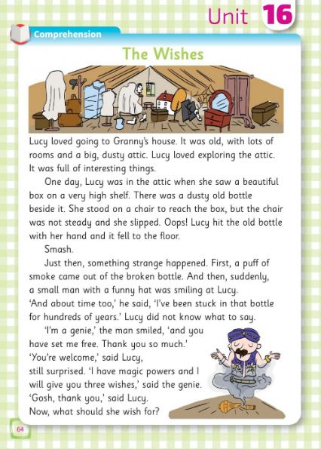

Answer these questions – remember to use full sentences in your answers. Use attached writing – make sure you are forming all letters correctly

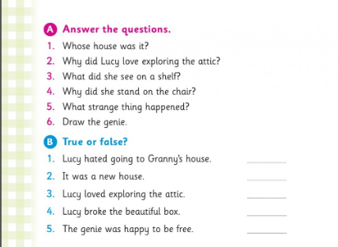

Spellings
New vocabulary/spellings into sentences
Week 1st June 2020
Third | Born | Thirty | Horn | Thirsty | Torn | Birthday | Morning

Handwriting –

Read the words below and try writing them using your best attached writing.

Link to work: https://www.folensonline.ie/home/library/programmes/writeon-book1/ebook/ [P.37, 38]
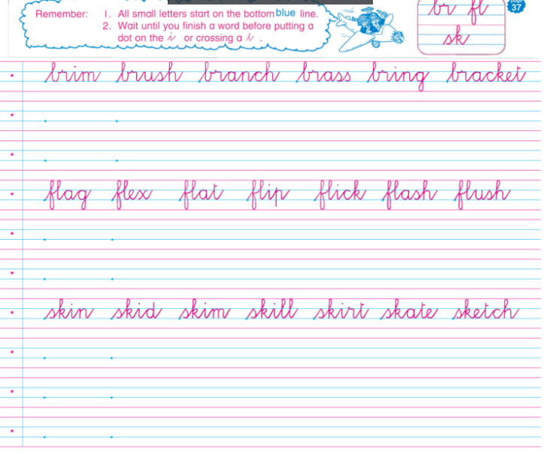

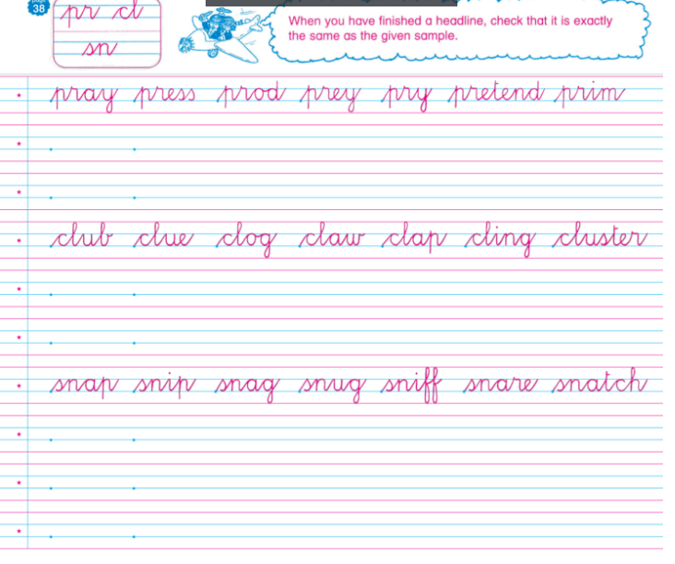

Link for the above is https://www.folensonline.ie/home/library/programmes/writeon-book1/ebook/ P. 37, 38]. Remember to access Folens website for first time, register as a teacher and use the code Prim20 for Roll Number. If you have accessed Folens website before, just log in with your details.

Maths:
- Mathletics to be done at home – Please do at least 10 minutes of Mathletics daily [Please email me at secondclassmarist@gmail.com if you need me to send on your Mathletics password]
- Tables work [+8]

- Count up in 4s

Link to work: https://my.cjfallon.ie/preview/student/20355/15 [P.13]

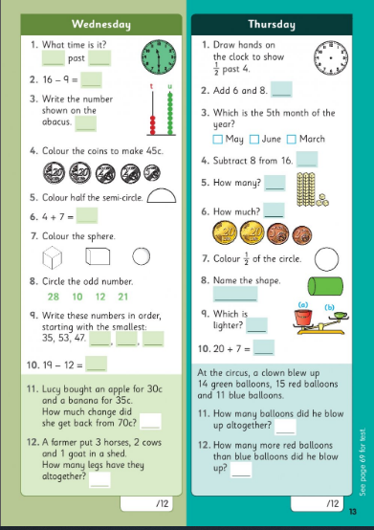

Place Value:
Link to work: https://my.cjfallon.ie/preview/student/10346/106 [P.100,101]

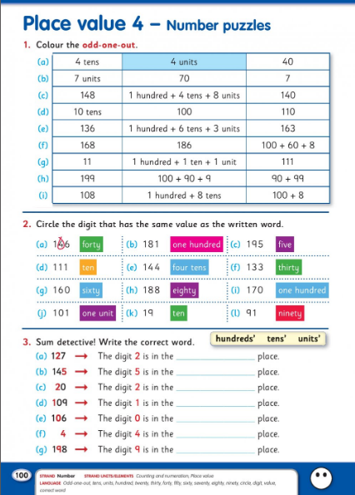

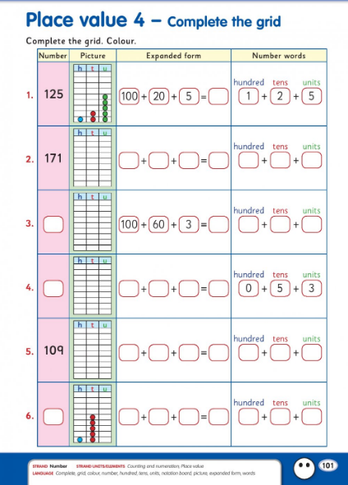

Maths Game – Find the number between...

https://www.topmarks.co.uk/maths-games/5-7-years/counting

Gaeilge:

- Duo lingo Gaeilge – a fun way to learn Irish online https://www.duolingo.com/learn

- Eist leis an scéal = Listen to the story

- Remember to access Folens website for first time, register as a teacher and use the code Prim20 for Roll Number. If you have accessed Folens website before, just log in with your details.

Ceolchoirm na Scoile = School Concert

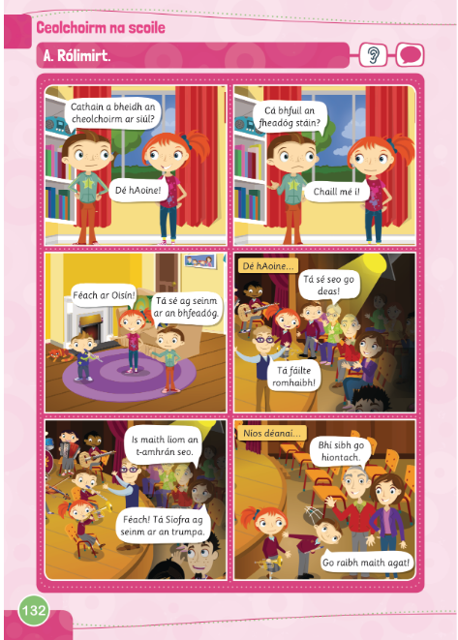

Éist leis an scéal = Listen to the story
https://content.folensonline.ie/programmes/AbairLiom/2nd_class/resources/Dialogue/AL_2C_ACT_Comhra_L26_002/index.html

Translation of story:
Cathain a bheidh an cheolchoirm ar siúl? Dé hAoine! | When is the concert on? Friday!
Cá bhfuil an fheadóg stain? Chaill mé í! | Where is the tin whistle? I lost it!
Féach ar Oisín! Tá sé ag seinm ar an bhfeadóg | Look at Oisín! He is playing the whistle.
Dé hAoine... Tá sé se go deas. Tá fáilte romhaibh! | On Friday...This is lovely! You are all welcome!
Is maith liom an t-amhrán seo. Féach! Tá Síofra ag seinm ar an trumpa! | I like this song. Look! Síofra is playing the trumpet!
Níos déanaí... Bhí sibh go hiontach. Go raibh maith agat! | Later on.... You were all brilliant. Thank you!

Game - Tráth na gceist – Ceolchoirm na Scoile = Quiz – School Concert
https://content.folensonline.ie/programmes/AbairLiom/2nd_class/resources/Vocabulary_games/AL_2C_GAME_Flashcard_L26_003/index.html

SPHE:

Everybody Worries

We hope you enjoy reading this story. Lots of things have changed for us in the last few months and you might be feeling a little bit worried. This story reminds us that it’s okay to worry. We all worry about different things! It is important to talk to someone about what things can cause you to worry?
https://en.calameo.com/read/000777721945cfe5bb9cc?authid=Xu9pcOzU3TQx

SESE:

History:

Here is a timeline. Read the story of Florence Nightingale and follow the timeline. Next week we will look at creating your own timeline.
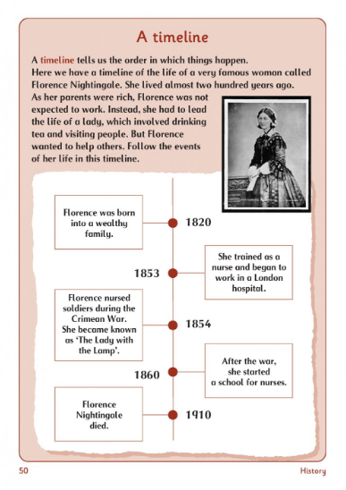
Geography

Here is a game to check if you remember your Irish counties. Have fun!
https://world-geography-games.com/europe_ireland.html

Science:
Link to work: https://my.cjfallon.ie/preview/student/1345/72 [Page 73]
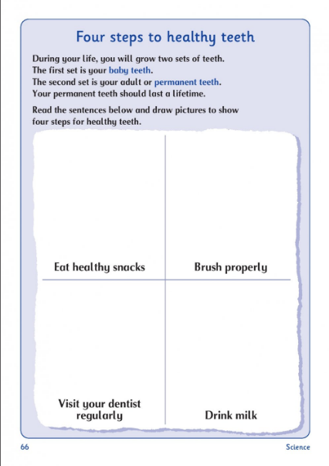

Music:
Click here to view Music plan from Ms. Barry this week. Have fun!

PE:

- Dance with Maeve!
Rhythm is a Dancer
https://www.youtube.com/watch?v=WQLhcKRu0fA

Religion:
Prayers – revise the prayer ‘The Confiteor’
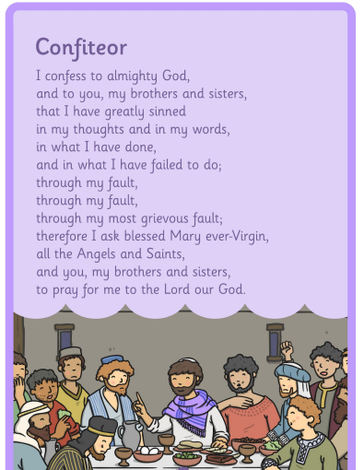

Art:
Here is a step by step guide on how to make a paper boat – you can decorate your boat when you have finished. Have fun!
https://www.youtube.com/watch?v=cRzyHskrQb4
Ongoing work:
RTE Home School Hub: On RTE2 at 11.00am daily – children can watch and engage with curriculum based topics and fun activities.
As I said, I would really love to see how you are all getting on with your work. You can email your work to secondclassmarist@gmail.com. Please stay safe and enjoy your time with your family.
Ms. Mullins

