Suggested Weekly Work for 5th class – 3/6/’20 - 5/6/’20
A note from teacher:
Hello to all my girls,
I hope you enjoyed the long Bank Holiday weekend? The weather has been absolutely glorious so I hope you made the most of the sunshine?
Welcome to the last month of 5th class! Can you believe it is June already! I hope to add in some fun summer activities for you to try at home this month!
I loved getting samples of all your work last week. You are doing really well with the work that I am sending. Keep it up! Please continue to email me with your work and with any questions you have. I am happy to help in any way I can. Remember my email address is fifthclassmarist@gmail.com
Some of you send me weekly updates and I really love reading those! It is great to hear how you are all getting on. Lots of you are enjoying the family maths challenges so I have added in a few more for this week!
I have given you a new list of work for this week. As this week is a short week I haven’t given as much as normal! Continue to do your best with this work.
I want to wish a big “Happy Birthday” to Ruby Troy. Ruby will be 11 years old on Tuesday! Have a fantastic day Ruby!
Have a great week girls,
Keep safe everyone,
Ms. Tiernan

English
Reading:
1)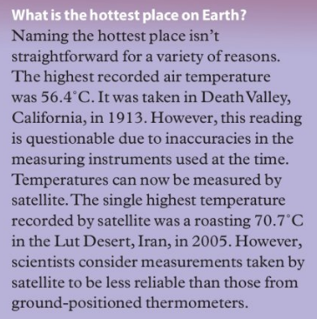 | 3)
2) | 4) 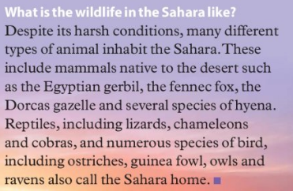

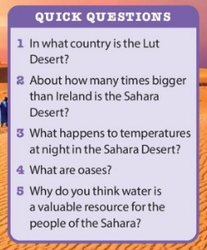
I know some of you enjoy reading books by David Walliams. Click on the link below and listen to some short stories written and read by David Walliams.
https://www.worldofdavidwalliams.com/elevenses/

Comprehension:
This week we are focusing on Poetry. Here I have included the poem “Digging” by Seamus Heaney, one of Ireland’s most famous poets. Read the poem a number of times to familiarise yourself with it. I hope you enjoy the poem, it is very descriptive and contains beautiful imagery.
Digging
by Seamus Heaney
Between my finger and my thumb
The squat pen rests; as snug as a gun.
Under my window a clean rasping sound
When the spade sinks into gravelly ground:
My father, digging. I look down
Till his straining rump among the flowerbeds
Bends low, comes up twenty years away
Stooping in rhythm through potato drills
Where he was digging.
The coarse boot nestled on the lug, the shaft
Against the inside knee was levered firmly.
He rooted out tall tops, buried the bright edge deep
To scatter new potatoes that we picked
Loving their cool hardness in our hands.
By God, the old man could handle a spade,
Just like his old man.
My grandfather could cut more turf in a day
Than any other man on Toner's bog.
Once I carried him milk in a bottle
Corked sloppily with paper. He straightened up
To drink it, then fell to right away
Nicking and slicing neatly, heaving sods
Over his shoulder, digging down and down
For the good turf. Digging.
The cold smell of potato mold, the squelch and slap
Of soggy peat, the curt cuts of an edge
Through living roots awaken in my head.
But I've no spade to follow men like them.
Between my finger and my thumb
The squat pen rests.
I'll dig with it.

Questions;
- What is suggested by the simile in the first verse? (as snug as a gun)
- What does the poet admire about his father and grandfather?
- Was the poet proud of his father and grandfather? Explain.
- What does the poet mean by the last line of the poem?
- This poem appeals to the senses, what part appeals most to your senses?

- Write a summary of the poem, what is happening in the poem, what feelings are present, imagery etc. did you enjoy the poem?
- Describe an occasion when you were proud of one or both of your parents for something they did. How did you feel and how did you react?
- Describe a childhood memory where you and your parents were doing an activity together. What was particularly enjoyable/unpleasant about the experience? Try to use your senses to describe the occasion.

Grammar:
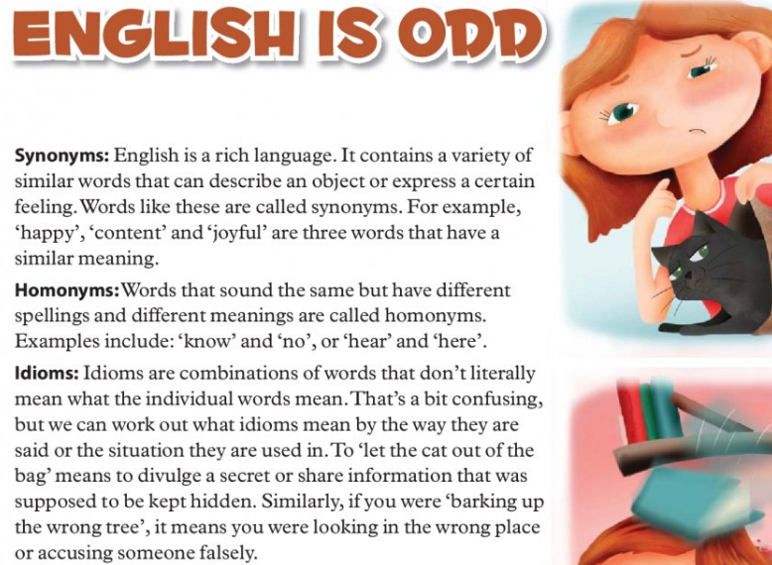
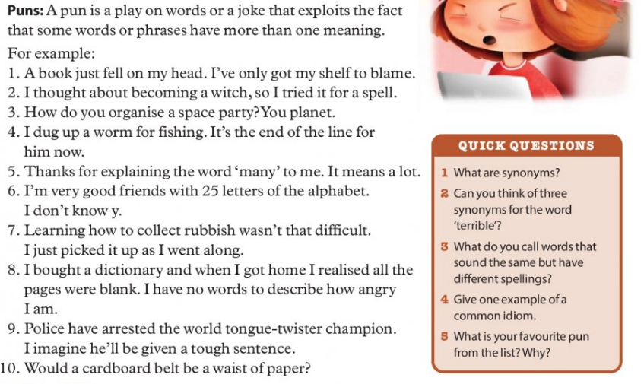

Spellings: Week 34
check | beverage | rogue | machine
cheque | material | league | machinery
groan | argue | success | brochure
grown | argument | successful | parachute

Look up these words in your dictionary and write the meaning in your vocabulary copy.
Continue to learn your vocabulary each day and try to use your new words in a sentence.

Gaeilge:
Abair Liom: An Aimsir: lch 139, 140, 141
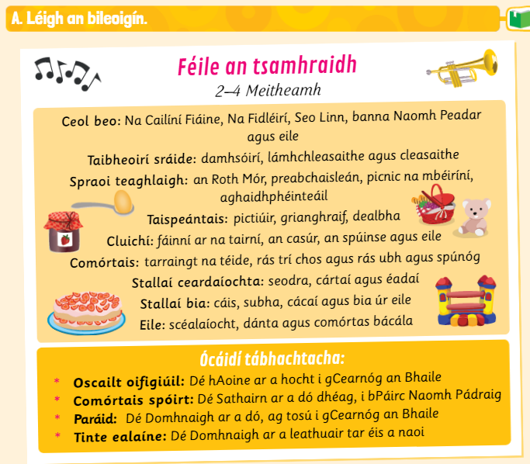
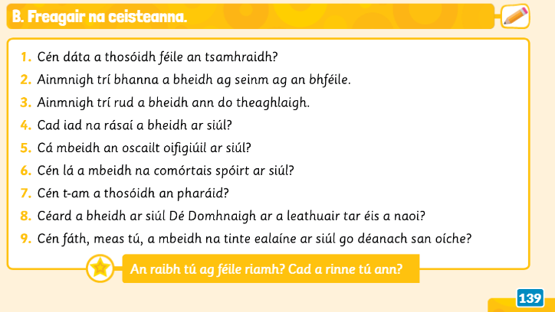
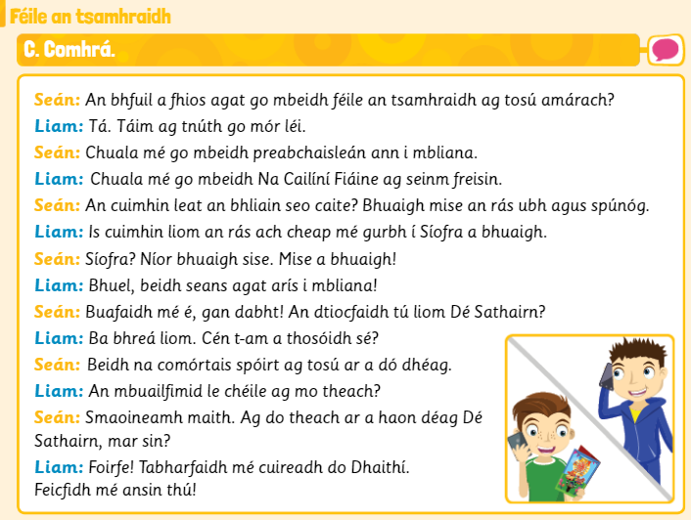
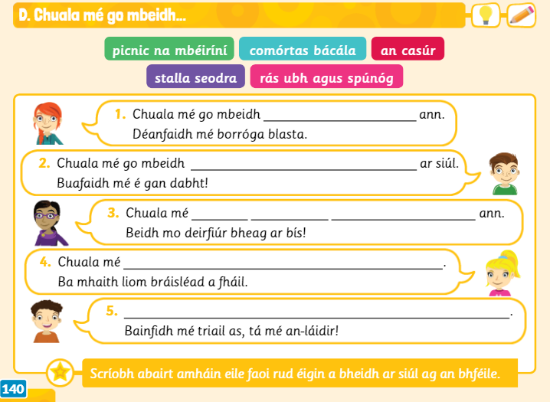
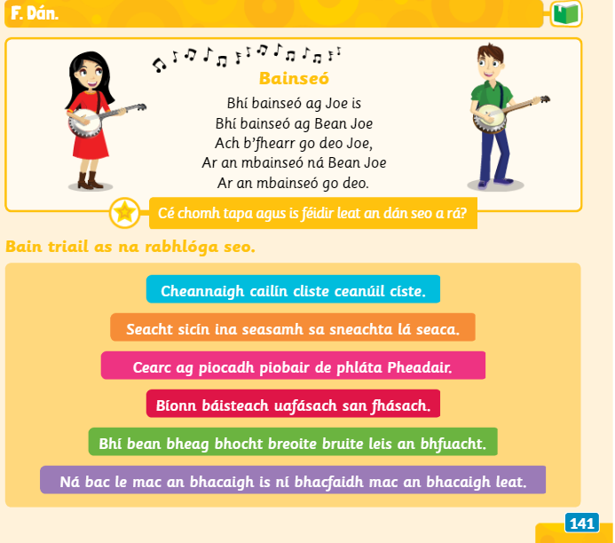
https://www.folensonline.ie/home/library/programmes/abair-liom-5th-class/ebook/

Duo lingo Gaeilge – a fun way to learn Irish online https://www.duolingo.com/learn
Fóclóir/Vocabulary:

ceol beo- live music | stallaί ceardaίocha- craft stalls | aghaidhphéinteáil- face painting
taibheoirί sráide- street performers | tinte ealaίne- fireworks | picnic na mbéirίnί- teddy bears picnic
spraoi teaghlaigh- family fun | preabchaisleán- bouncing castle | rabhlόga-rhymes/ tongue twisters

Maths:

- Mathletics to be done at home – [If you have lost your login details, please let me know and these can be forwarded to you directly]

Busy at Maths 5 Chapter 16: Long Division of Decimals pg 85, 86 and 87
Strand: Number
Strand Unit: Operations

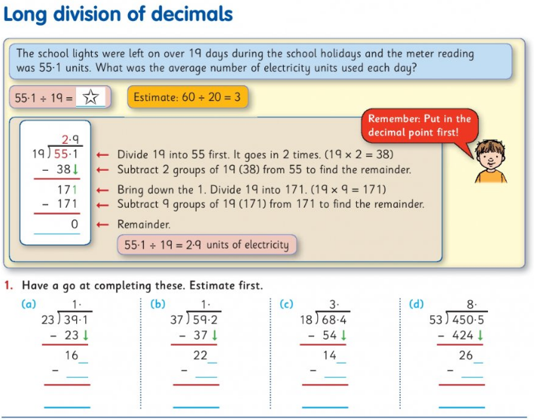
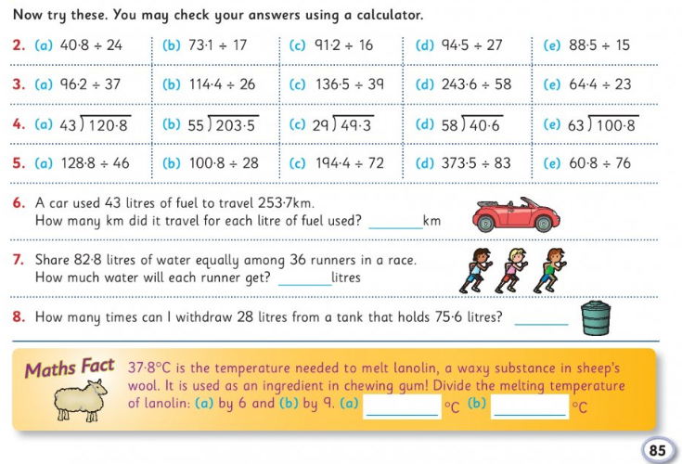
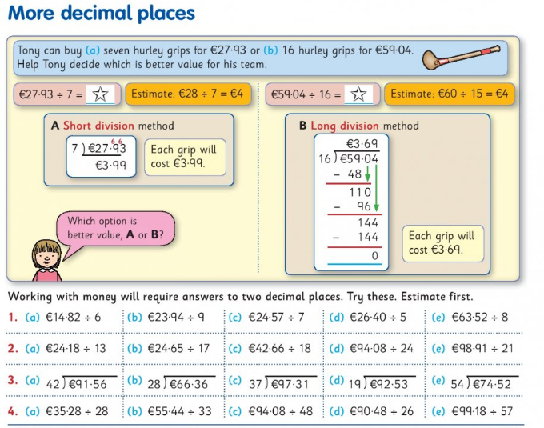
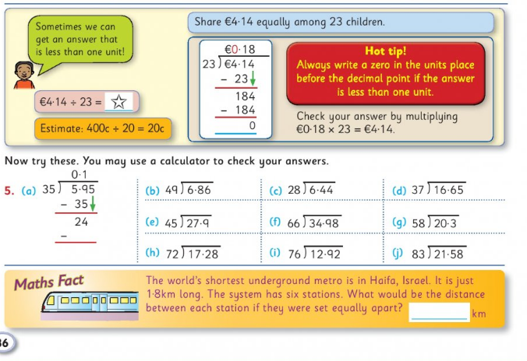

Try these word problems. You must decide if you should multiply or divide.
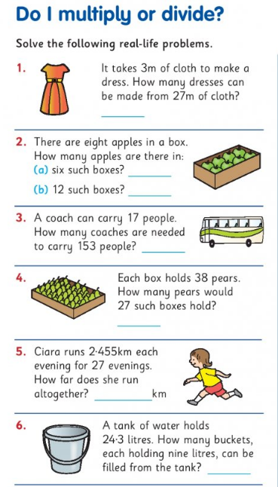
Maths Challenge for the whole family!
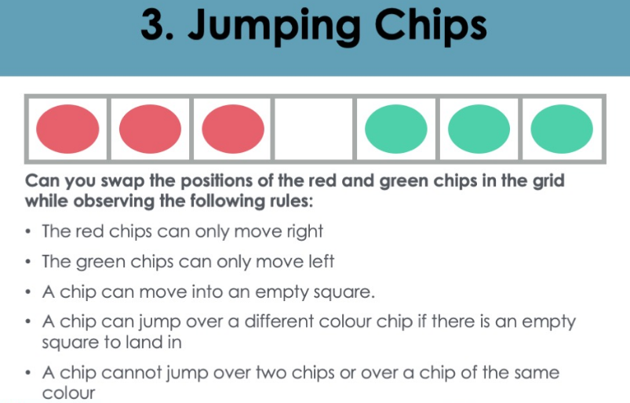

Some of you know the solution to this puzzle already but ask your family to give it a go and see how they get on!
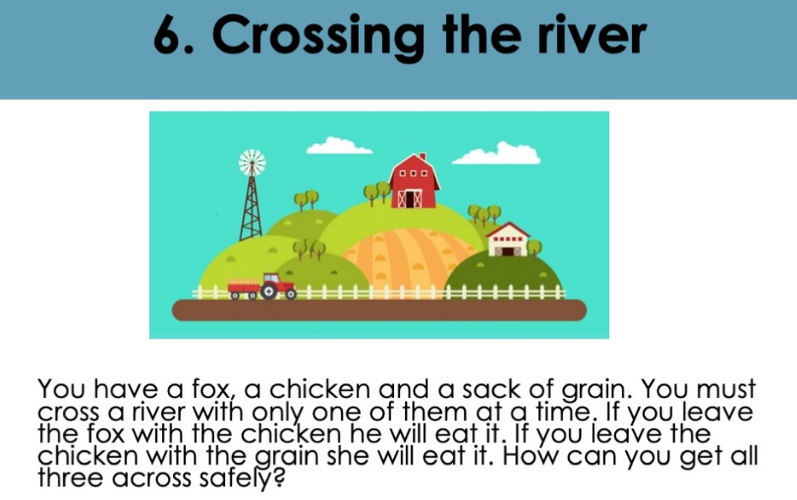

SPHE:
Take a look at these Personal Safety Rules. Read them and discuss them with your parents. Make a list of the people in your life that you feel you can trust. Design a poster to remind you of the ways in which you can Stay Safe.

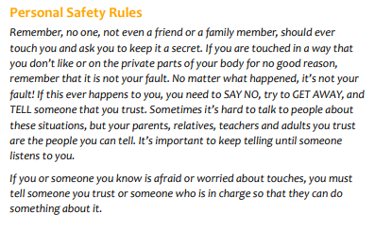

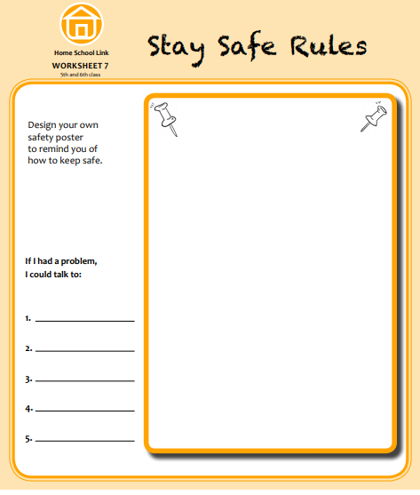
I have three new breathing strtegies for you to try this week.
Remember, your breath goes everywhere with you!
These strategies will help you to relax and find a sense of calm and peace when faced with overwhelming emotions or challenging situations.
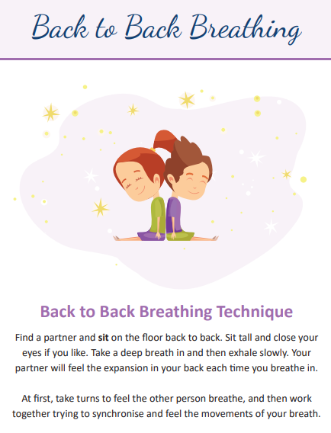 |  | 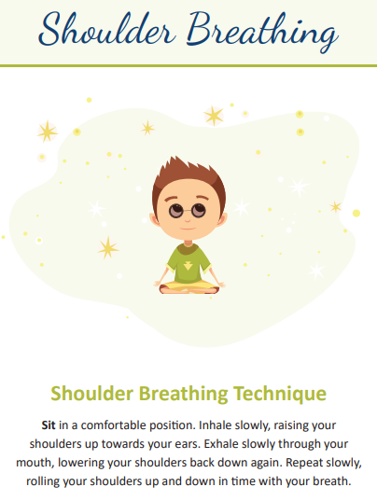

SESE:
Science:
I was very impressed with everyone who went on their spider safari last week. You are very brave!!
This week we will be learning all about materials. We are going to test the absorbency of different materials found around your home.
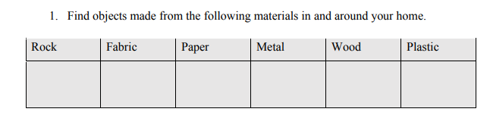
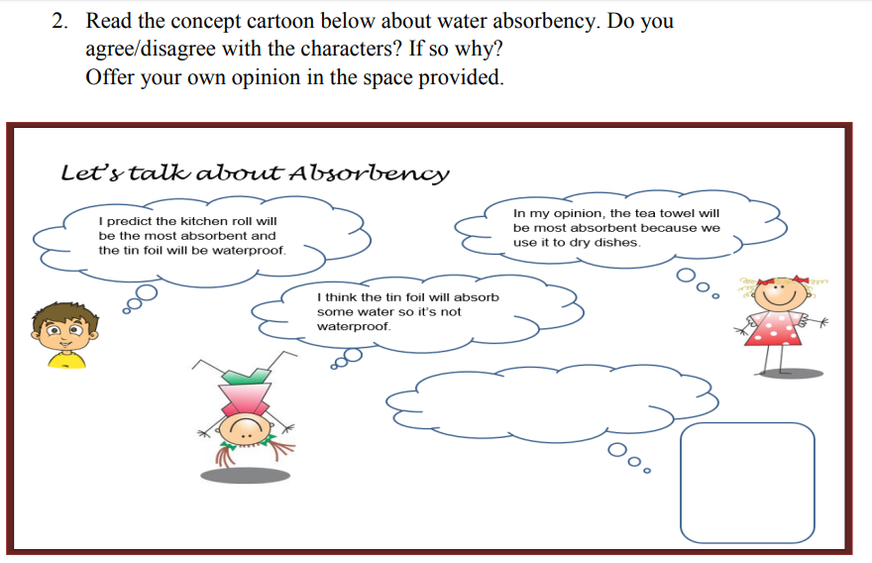
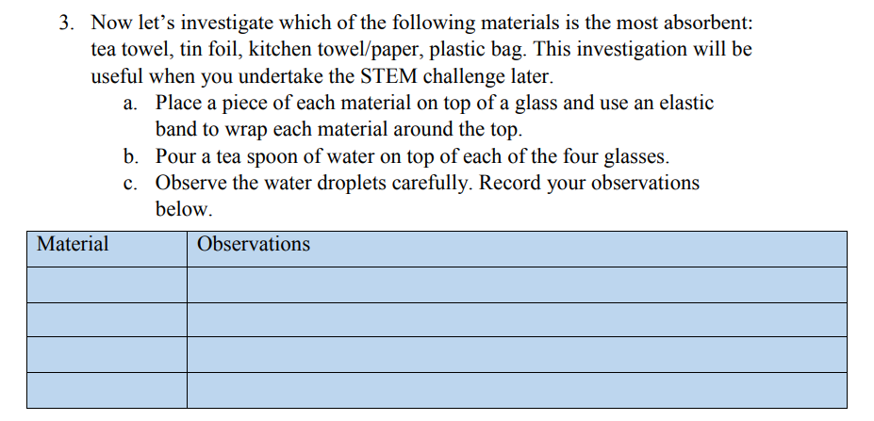

STEM Challenge- Create a chair

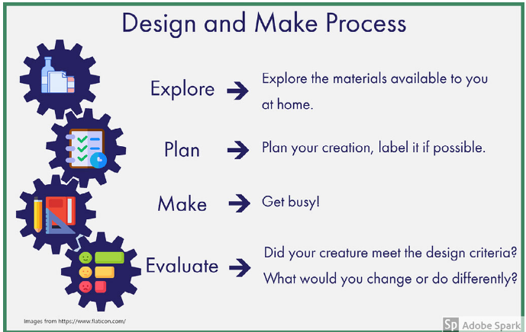
Goldilocks and the Three Bears is the stimulus for this week’s Stem Challenge. Goldilocks has broken Baby Bear’s chair and I need you to make a new one!

Your Task: Using the Design and Make Process, build a new chair for Baby Bear.
- Your chair must be free standing
- Your chair must be able to hold one of your teddies
- The legs should be at least 10cm in height
- Your chair will be used in the sitting room so comfort is important
- The seat of the chair must be made from an absorbent material.
Let your imaginations run wild! I can’t wait to see what you come up with! Have fun!

You all did a great job creating creatures last week. I hope you enjoyed it!

PE:
P.E with Joe Wicks The Body Coach:
https://www.youtube.com/thebodycoachtv

Former Mayo Footballer Andy Moran does a live P.E class every Monday, Wednesday and Friday at 12 o’clock. Search for Leisure Complex at Lough Lannagh/The movement Gyms on Youtube. The link below will bring you to a class from last week.
https://www.youtube.com/channel/UCXVBIJ0AifnJvAziCtQsWTA
Let me know what you think!!

Religion:
To help teachers, students and parents during this difficult time Grow in Love granting free access to Grow In Love AND Soul seekers online series. Simply login on the www.growinlove.ie website with the following details:
Email: trial@growinlove.ie
Password: growinlove
https://app.growinlove.ie/en/user/theme-lessons/138
This week we are looking at Theme 10: The Mass.
Lesson One: In the Road to Emmaus

Music
Ms. Barry has kindly sent a new music lesson for you to try! I hope you enjoy it.
Clink on the link on the fifth class page on our website for more Music activities.

Art
I loved the drawing you sent me last week. They were absolutely amazing!
Click on the YouTube link below and follow the steps to help you draw pictures by tracing your hand. All you will need is paper and a pencil.
https://www.youtube.com/watch?v=qJNSOte9h4I

Ongoing work:
If you are doing any other fun activities at home with you family such as baking, arts and crafts, experiments or exercise activities, take pictures or write about them and tell us all about them when we are back at school.
Remember to be good for your parent’s girls and to help out at home whenever you can.

Our thought for the week this week is:
“The capacity to learn is a gift; the ability to learn is a skill; the willingness to learn is a choice”
-Brian Herbert-
Remember girls you can email me with your work or questions and I will get back to you as soon as I can.
fifthclassmarist@gmail.com
Have a great week!
Ms. Tiernan

