Unusual and Ancient Instruments from around the world.
5th and 6th classes
First we will look at some very cool ancient instruments
- Over thousands of years musical instruments have become more complex and technical.
- We have changed the materials used and the makers now have to go through years of training to become expert intrument makers
- The oldest instrument I can think of is one that we still use today, can you think what it is?
- Your VOICE!!
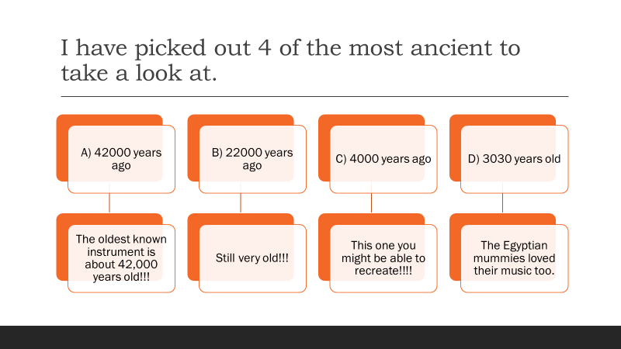
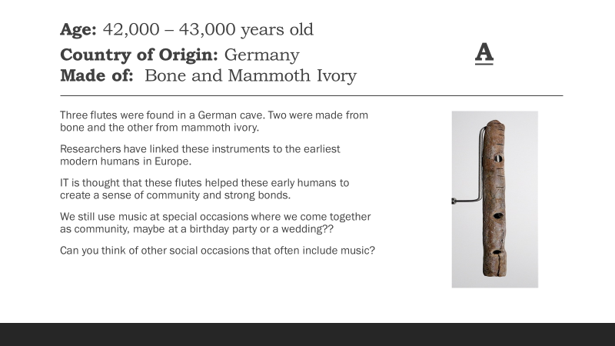

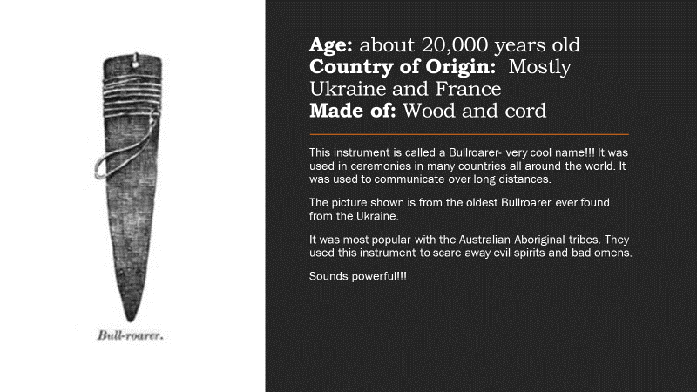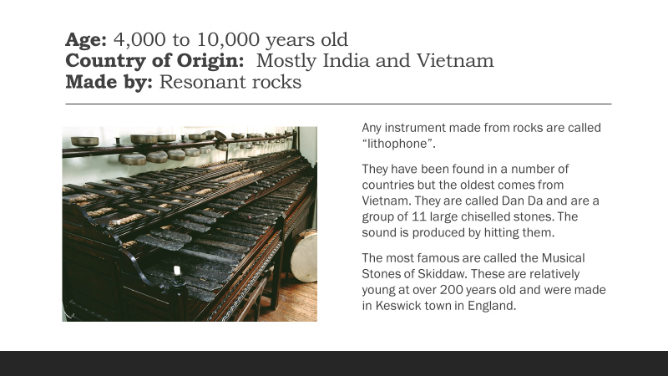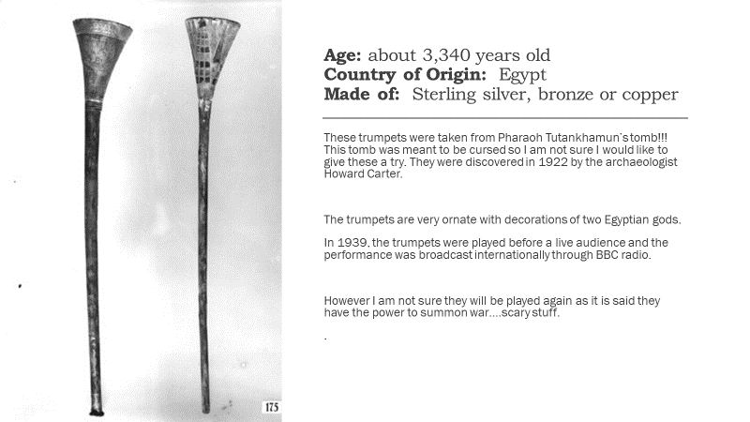
Here are a couple of links to some of the instruments mentioned above.
The Bullroarer: https://youtu.be/1tvreQ3hTvA
The ancient trumpets: https://youtu.be/HO3P5jkQmgU

This next instrument is not to be attempted at home. I wonder who discovered a saw could make such beautiful sounds.
https://youtu.be/2sh1EH2GBF8
Last but not least this is my absolute favourite: https://youtu.be/xM1EjIDLMLY

