Suggested Weekly Work for Second Class – 22/06/’20- 30/06/’20
A note from teacher:
Hi to all the girls in 2nd class.
I hope you are all keeping well. This is the last plan of work before the holidays. You have all done brilliantly. This has been a year like no other and I know it has been hard at times but you should be so proud of yourselves and how well you have all done.
This week I’ve added some work on water safety – this is really important especially at this time of year.
Darcie Salmon and Laragh O’ Grady will be 8 years old this week. Wishing you both a very happy birthday. Have a super day!
Best wishes to Daisy Belle Nolan, Addison Fitzgerald, Leah Moore, Emily Seliger, Ellie Wade and Ruby Whelan who are also celebrating their birthdays during the summer holidays.
Thank you for all the lovely emails this week. If you have any questions or if there is anything I can help with, please email me at secondclassmarist@gmail.com before the 30th June. After this date, this email address will no longer be active.
Finally I just want to say well done to everyone for all your hard work during this time. I know it hasn’t been easy but I want you to know how proud I am of you all. It has been a pleasure to be your teacher this year. I hope you all have a fabulous summer and I am really looking forward to seeing you in September.
Keep safe and well,
Ms. Mullins
English
Reading:

Read the following emoji story about Little Red Riding Hood. Can you write your own emoji story?

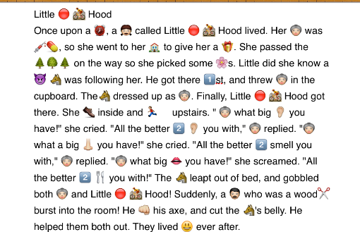

Handwriting –

We are going to finish your handwriting book. Look at all the beautiful work you have done this year on your attached writing. You should be so proud!

Remember to read the words and try writing them using your best attached writing. Read the instructions at the top of each page.

Link to work: https://www.folensonline.ie/home/library/programmes/writeon-book1/ebook/ [P.45-48]

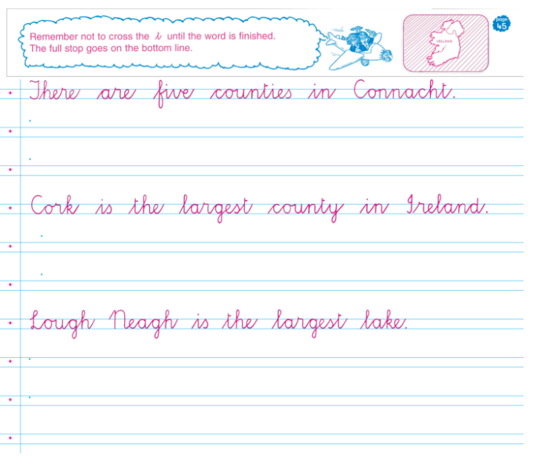
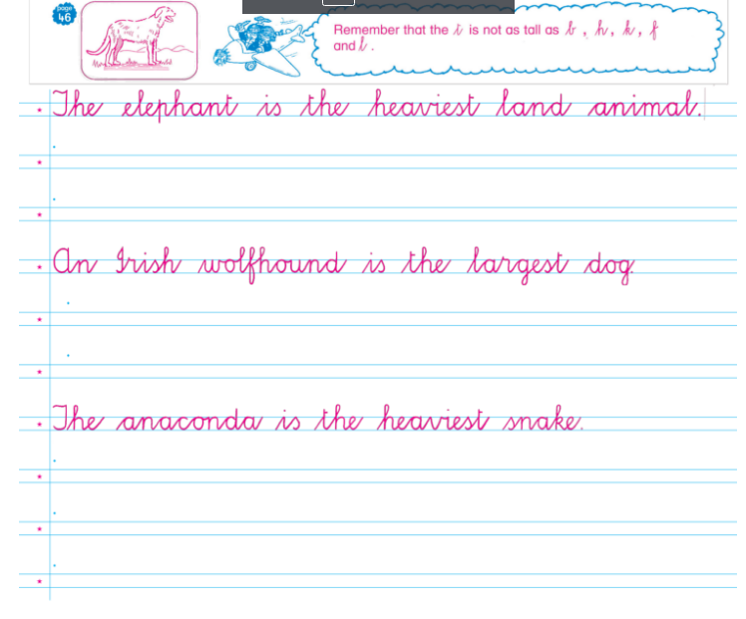

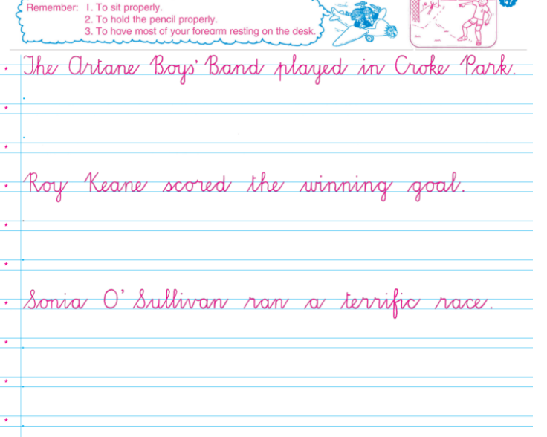

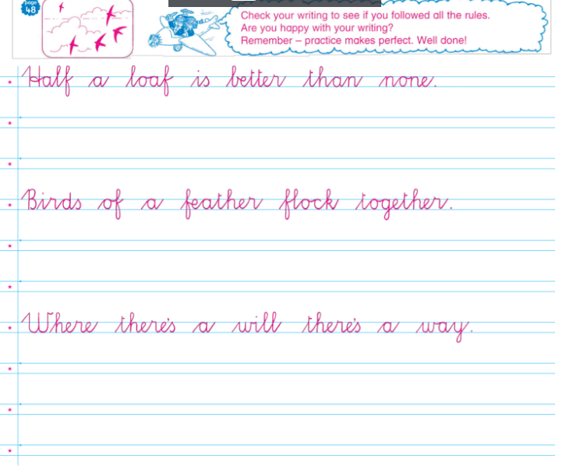

Grammar: Look Listen and Learn - to P.72
Link to work:
- https://my.cjfallon.ie/preview/student/1299/71#
- Anagrams
- Missing vowels

Maths:
- Mathletics to be done at home – Please do at least 10 minutes of Mathletics daily [Please email me at secondclassmarist@gmail.com if you need me to send on your Mathletics password]
- Tables work – Revise all addition and subtraction tables

- Count up in 9s and 10s

Here is a revision page for you:
Link to work: https://my.cjfallon.ie/preview/student/10346/170

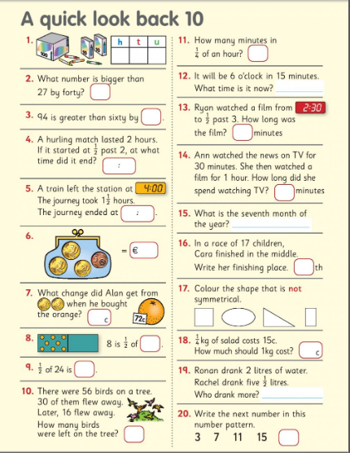

Maths Games –

Here are some games you can play if you have playing cards at home. Have fun!

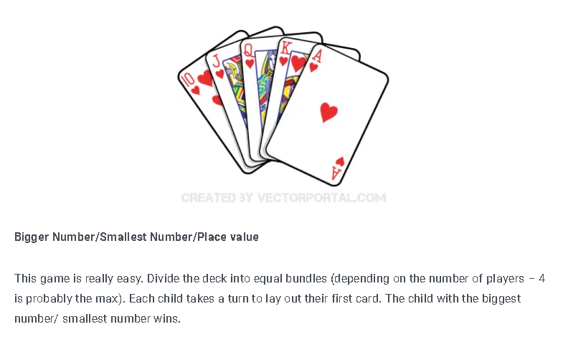

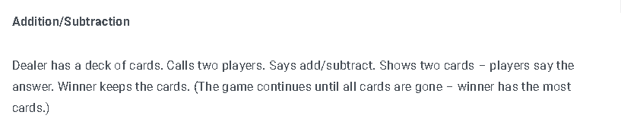

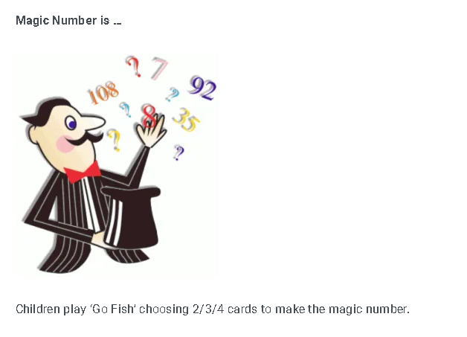

Can you solve this puzzle?

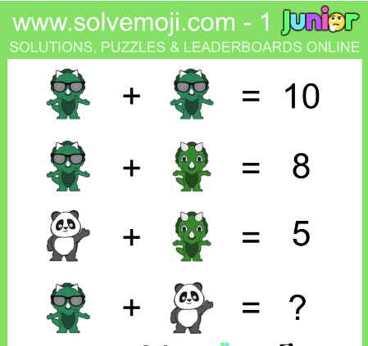
Hit the Button – Test your addition with this fun game:
https://www.topmarks.co.uk/maths-games/hit-the-button

Gaeilge:

- Duo lingo Gaeilge – a fun way to learn Irish online https://www.duolingo.com/learn

- Do you remember we did the story Cinnín Oir agus na trí bhéar [Goldilocks and the 3 bears]
Eist leis an scéal – Listen to the story

https://www.youtube.com/watch?v=91Aa8lBXUos

Revision - Game – Cliceáil ar an mbalún ceart – here are some revision games to practice your vocabulary:

https://content.folensonline.ie/programmes/AbairLiom/2nd_class/resources/Vocabulary_games/AL_2C_GAME_Waterblast_L01_003/index.html

https://content.folensonline.ie/programmes/AbairLiom/2nd_class/resources/Vocabulary_games/AL_2C_GAME_Balloon_L02_003/index.html

https://content.folensonline.ie/programmes/AbairLiom/2nd_class/resources/Vocabulary_games/AL_2C_GAME_MatchCards_L03_003/index.html

SPHE:

Now that you’re summer holidays are almost here, think about your hopes for this summer:
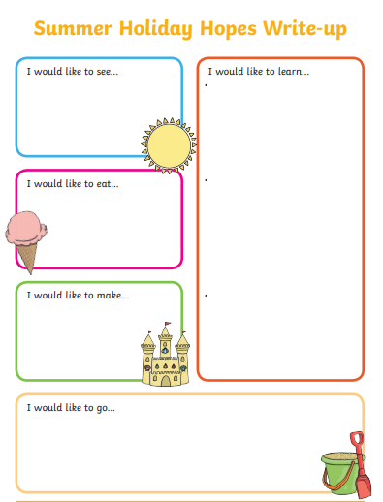

SESE:

History:

Now you are nearly finished 2nd class let’s take a trip down memory lane. Think about your year and all your happy memories!

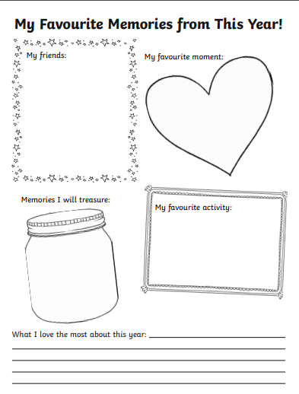

Geography

We live in the country of Ireland. Ireland is a country in the continent of Europe. Look at the countries in Europe:

http://www.yourchildlearns.com/online-atlas-europe.htm

Science:

Water Safety – Learn basic water safety skills at home!

Read the following story on water safety:

https://static1.squarespace.com/static/593f9c096b8f5b6f0ab3cade/t/5e2ec75f04deb513e4af33a0/1580124035356/PAWS+2+ENGLISH+WEB.pdf

Now here are some fun activities that will help to teach you about water safety:

http://paws.edco.ie/first-and-second-classes/

Look at the following video on water safety. You might recognise some of the characters!

https://youtu.be/K6Sm-YvFcRw

Music:

Click here to view Music plan from Ms. Barry this week. Have fun!

PE:

Dance with Maeve: Footloose

Here is a breakdown of the steps:
https://www.youtube.com/watch?v=Wrtk5sMNKR0

Now let’s try and put all those steps to the music – Have Fun!
https://www.youtube.com/watch?v=c2-rPgaSQ24

Religion:
Revise the Prayer Before Communion and the Prayer after Communion
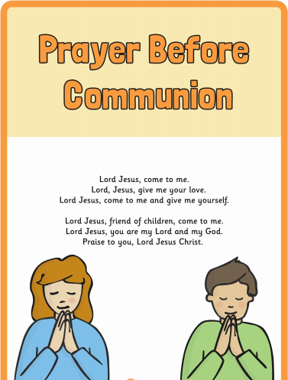

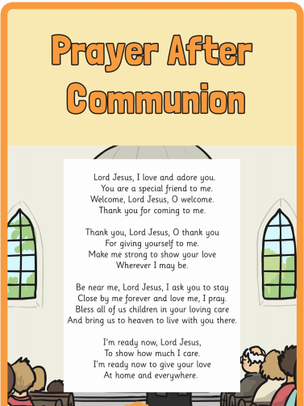

Art:
As you know girls we have done lots of work on mindfulness during the school year. Mindfulness is about enjoying the present moment and giving your mind time to relax. Here is some mindfulness colouring – why not try drawing your own pictures using mindfulness colouring!
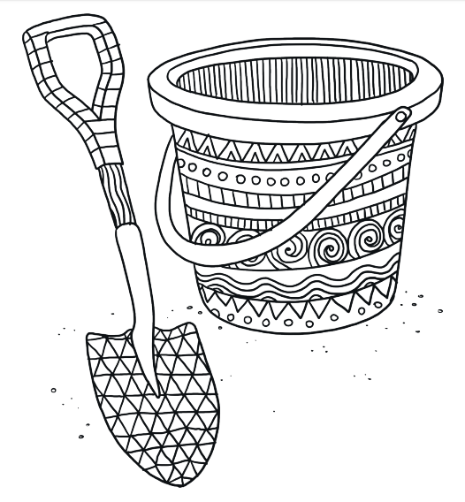

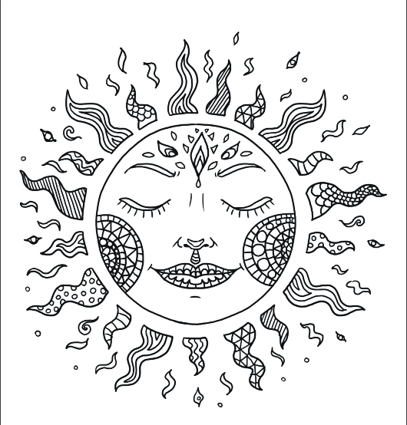

Fun activities for all:
Escape Room Challenge
Test yourself – Follow the clues – can you escape?
Cinderella
https://docs.google.com/forms/d/e/1FAIpQLSfX4nFPt04K7ePZYESFABj6FJ9gs7TQIF0ubEKU3s5LqlAXOA/viewform

Try this one – it’s a little bit trickier:
Alice in Wonderland
https://docs.google.com/forms/d/e/1FAIpQLSc4-g_PdCdGnThONdtmbQZdfIG1tfy_L2PedFrN-uCnN5nDlg/viewform?fbclid=IwAR0ifgUgKKMfzcvD9d-HUi4RpQLiNHfDPO99DQI2YS3TSnWio6LZgqgBkuU

Take a virtual tour of Áras an Uachtaráin where President Michael D. Higgins lives:
Áras an Uachtaráin: https://president.ie/en/explore-visit/interactive-tour

Virtual tour of ‘Aquarium of the Pacific’

Look at these amazing aquarium webcams. See penguins, sharks, moonjellies and Sea Nettles in the aquarium!
http://www.aquariumofpacific.org/exhibits/webcams?fbclid=IwAR066ca5EMnujYOY_UmsfucgEBzUDGSchnScA_00W0Kd8HT8X5UXeZ1ElvE

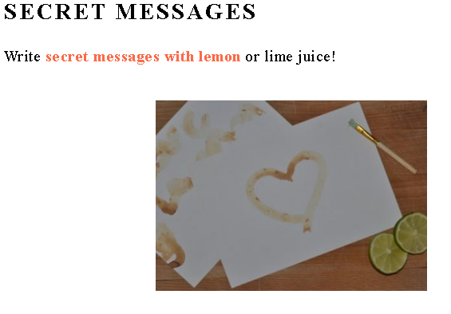

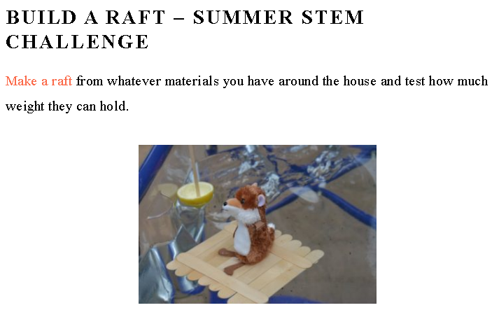

Again I want to wish you all a very happy and safe summer and thank you to all the wonderful girls in 2nd class. Also a big thank you to your teachers at home. They have done a fantastic job too. Have a brilliant summer.
Best Wishes,
Ms. Mullins

