Suggested Weekly Work for First Class – 22/6/’20 – 30/6/’20
A note from teachers:
We hope everyone in First Class is safe and well. We are now coming into the last week of the school year and we are so proud to see that you all have worked so hard and tried your best to complete your schoolwork. You all deserve a FANTASTIC summer and well done for being resilient during this strange time! We loved teaching all the boys and girls in First Class and each of you have made us so proud. Keep safe, keep reading and keep being kind, wonderful children.
Take Care,
Ms. Boyle & Mr. Doody
English: Reading: Beach Habitat & Beach Safety
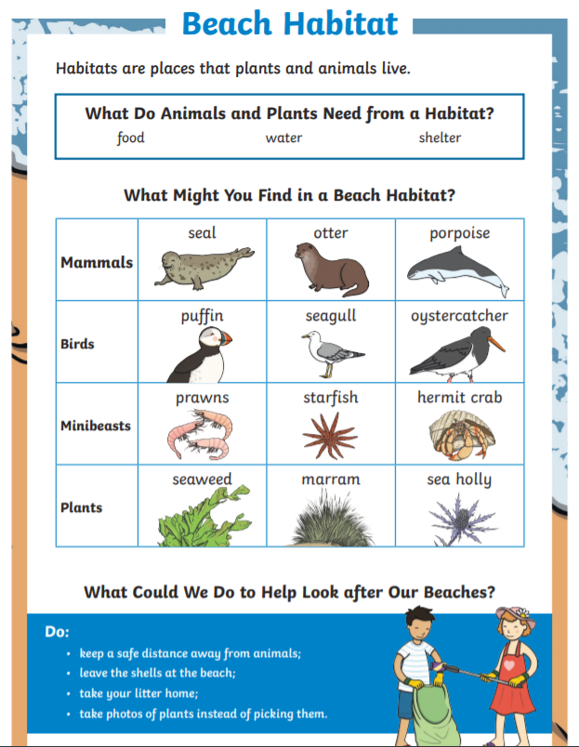
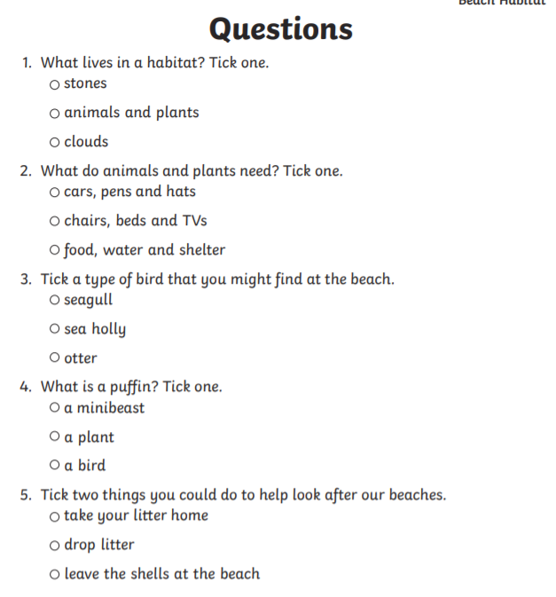

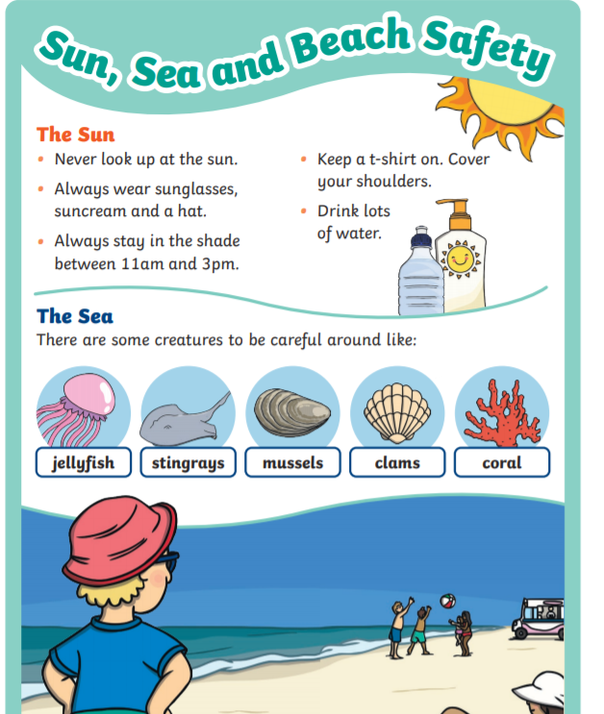

Life guards patrol our beaches. Here are some of their safety tips.

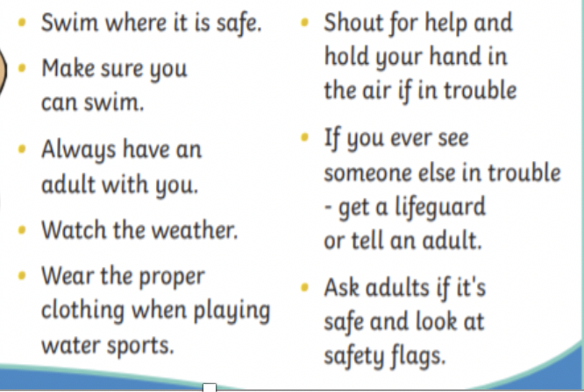

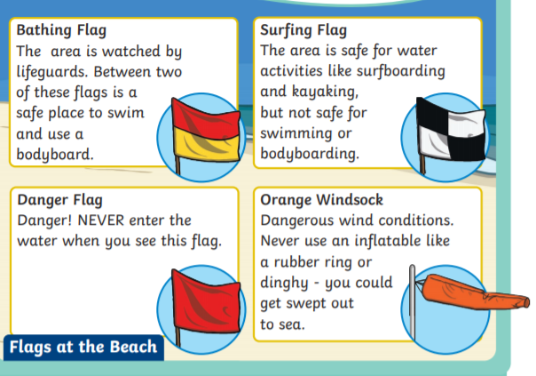

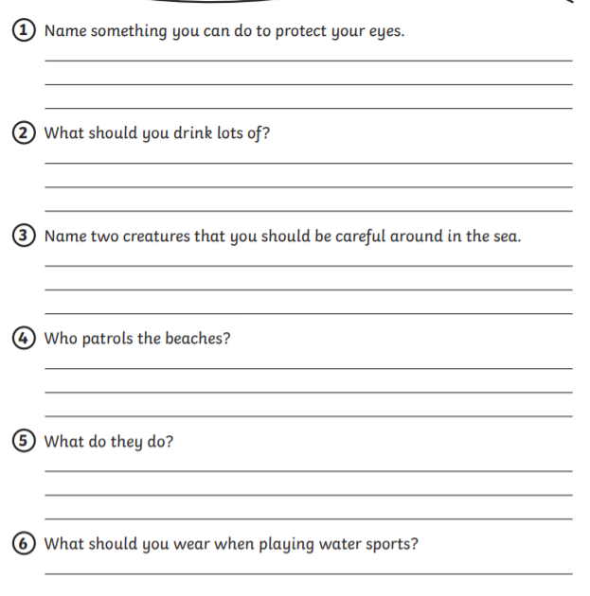
Water Safety Discussion Cards:
Please read and discuss the best possible action
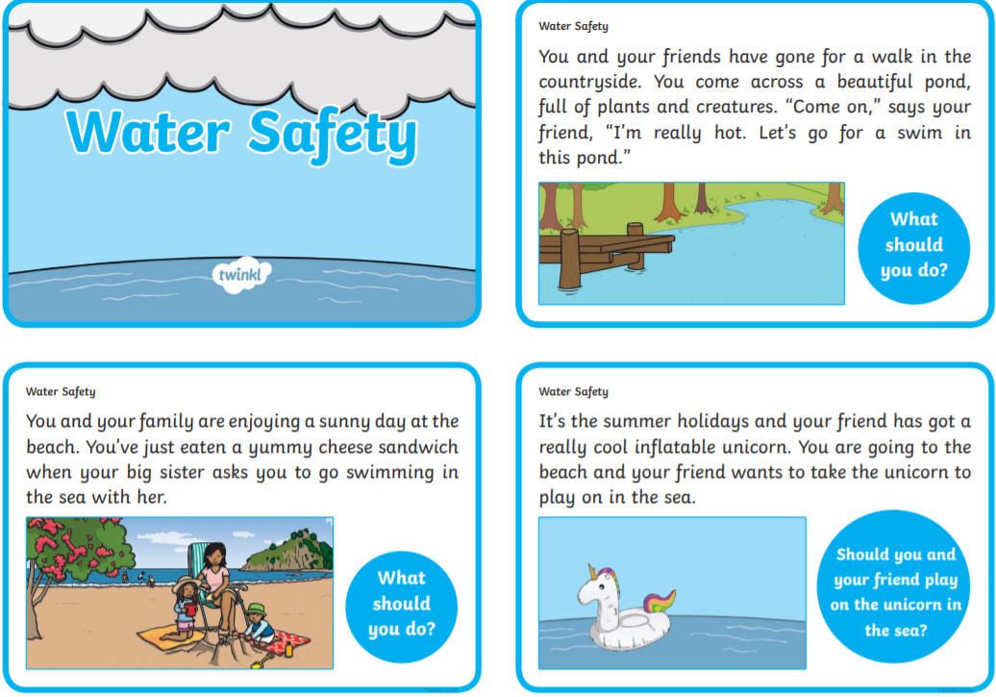

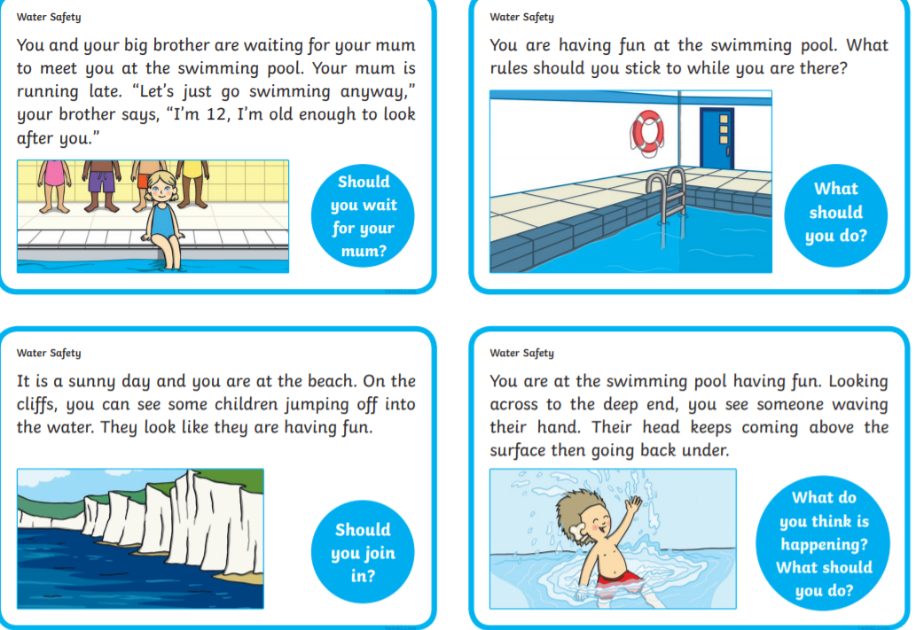

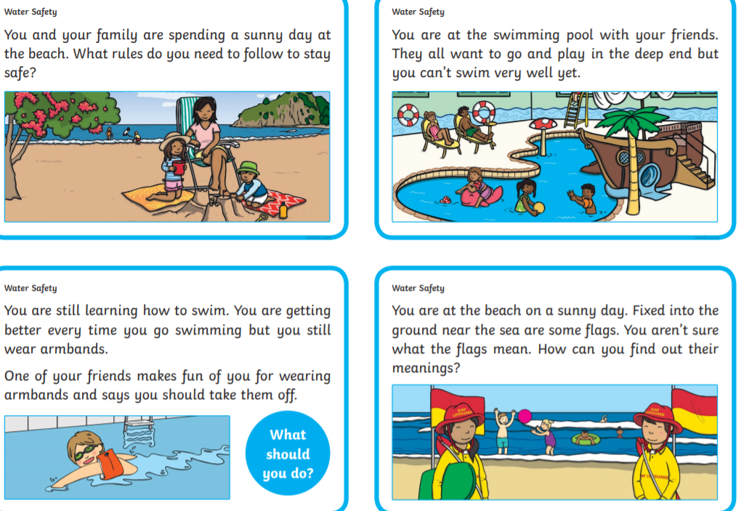

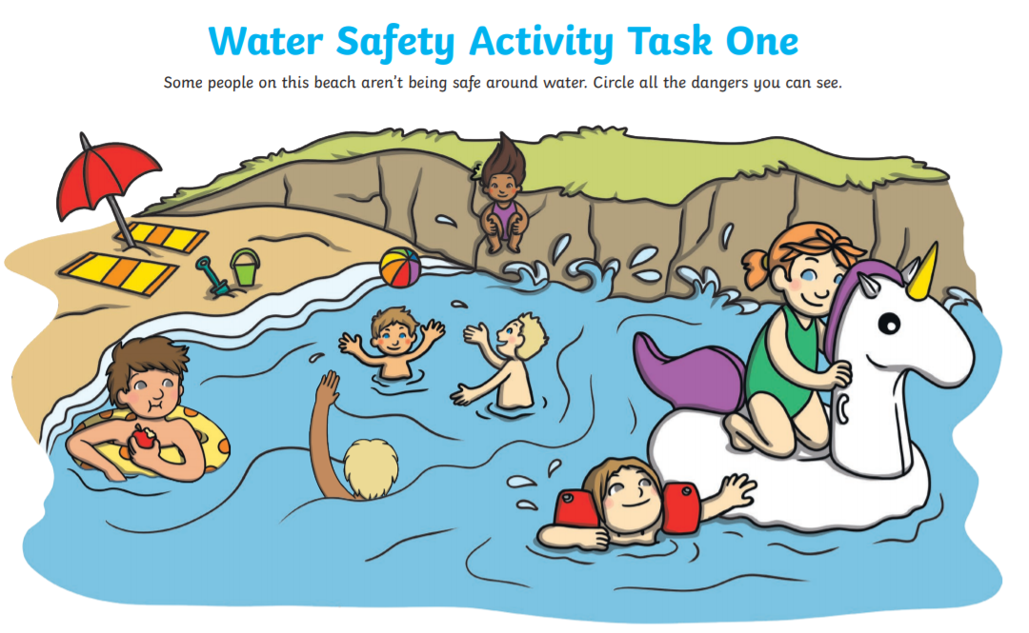
Water safety is so important. Make a list of the dangers you can see in the picture!

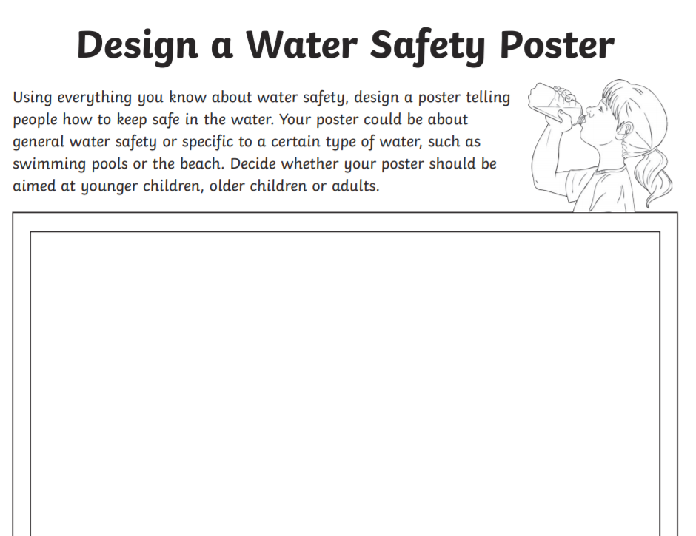

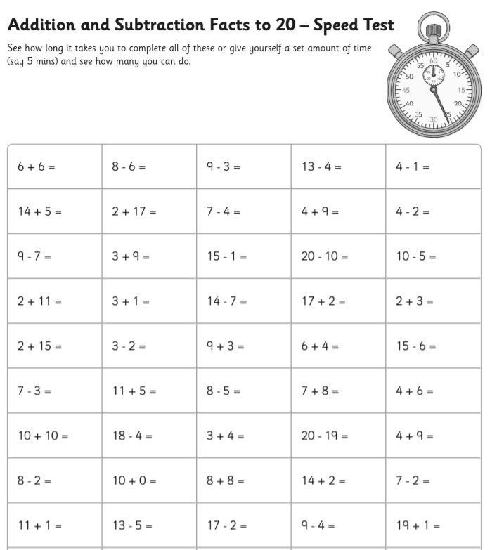
Colour this delicious ice cream
Maths: Revision

Maths:

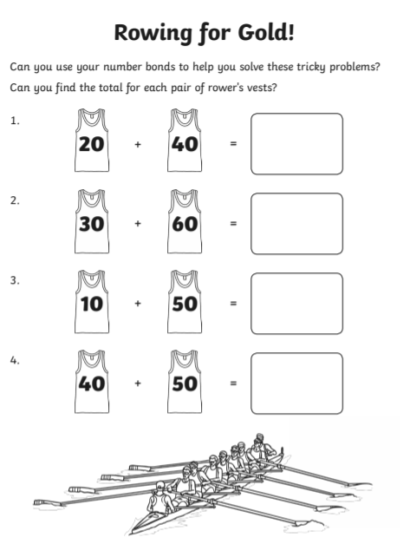
Challenge

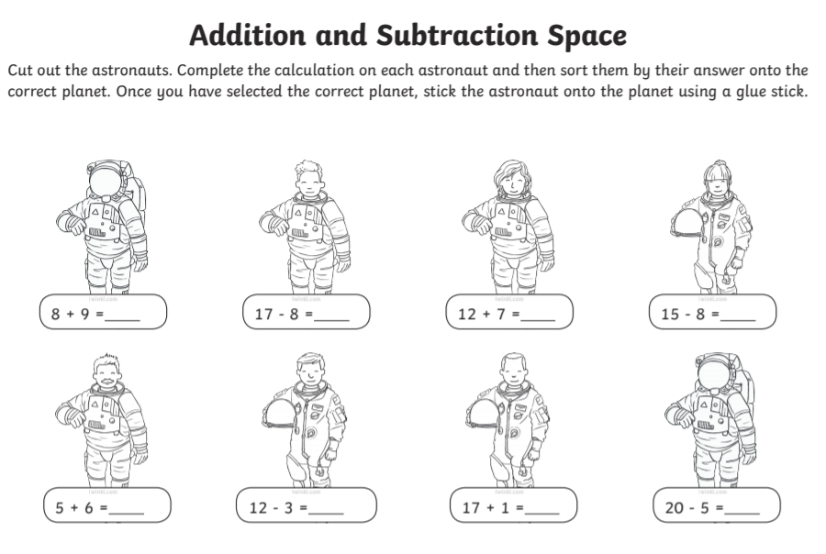

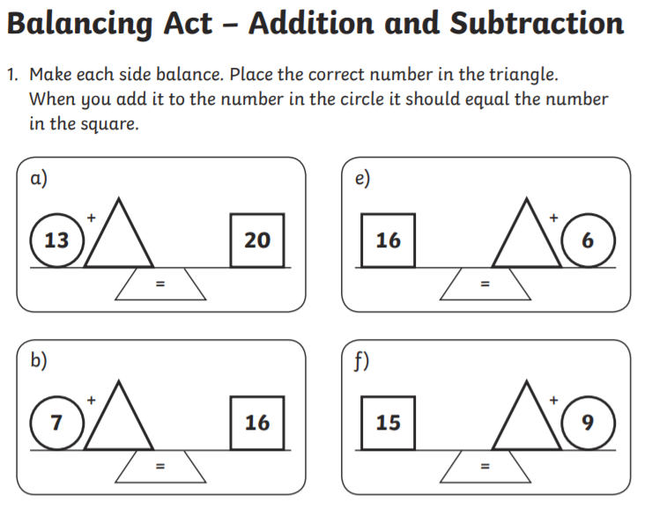

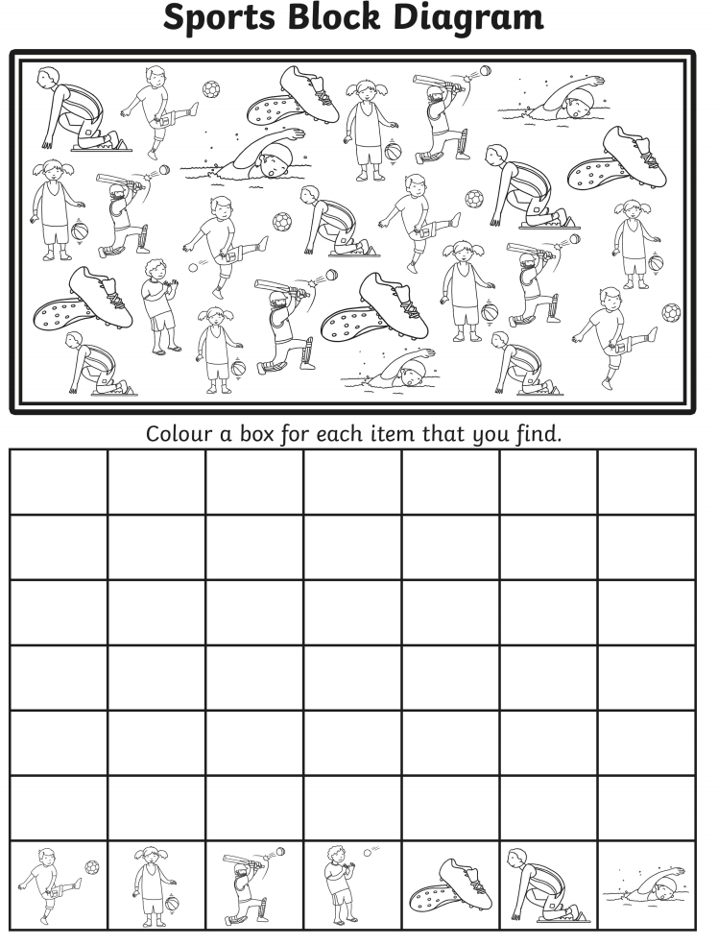
Gaeilge: Look up words to find the English translation of the words you don’t know.(Daithaigh = colour)
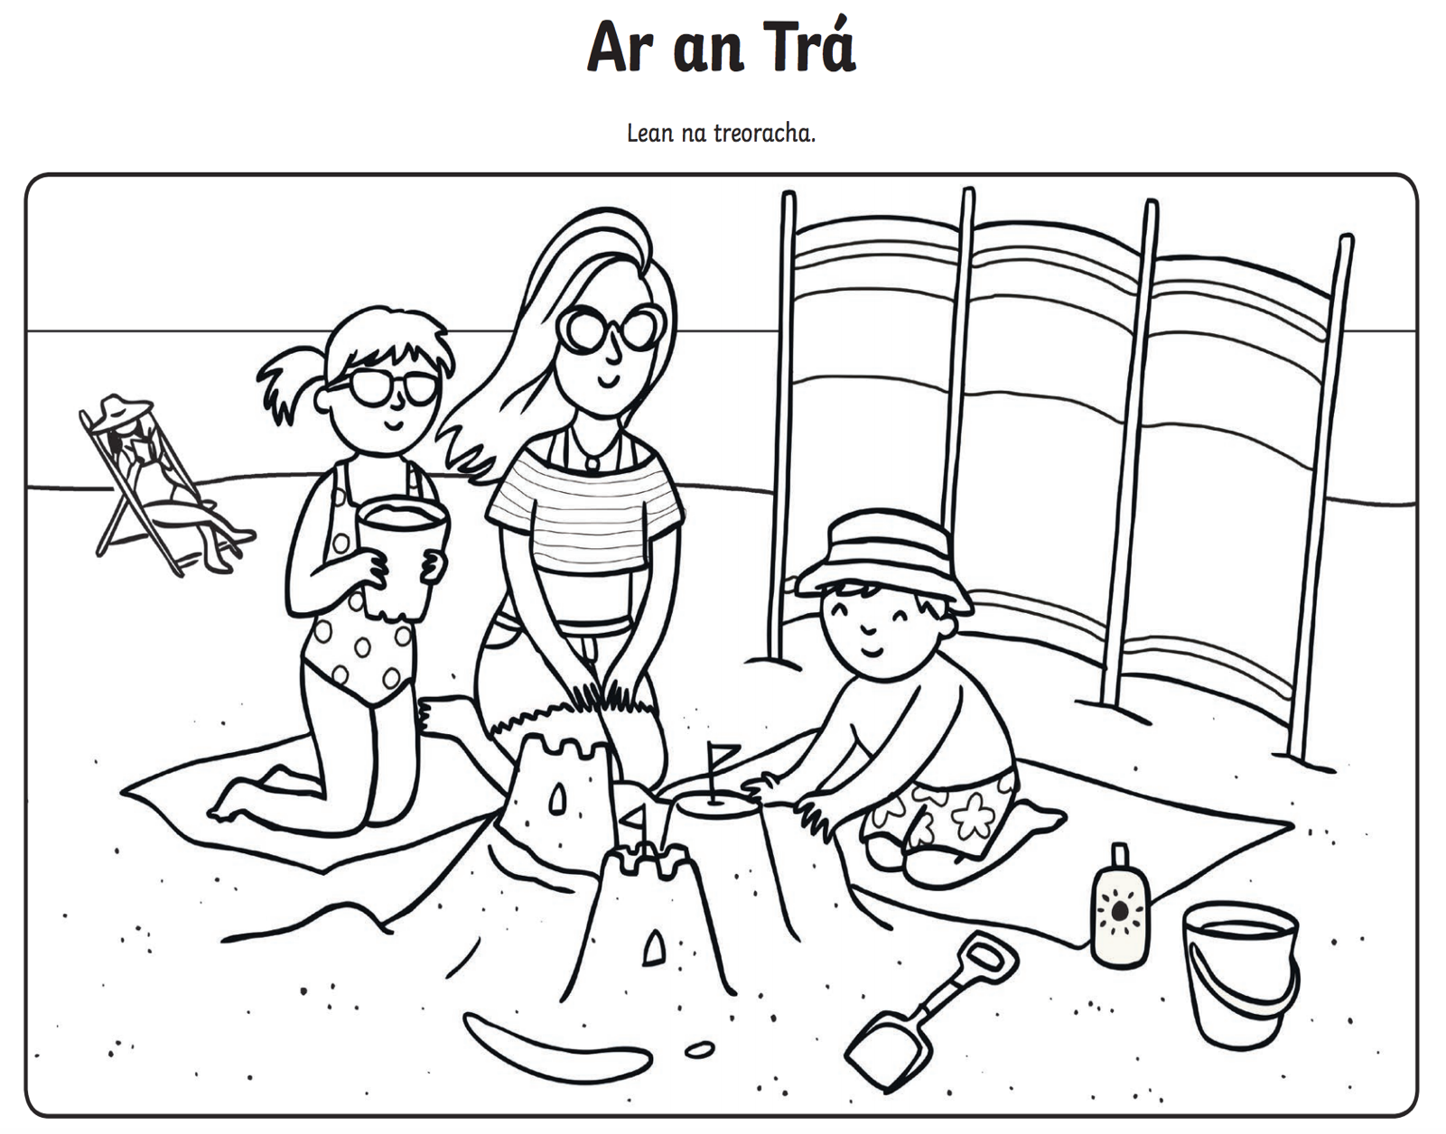
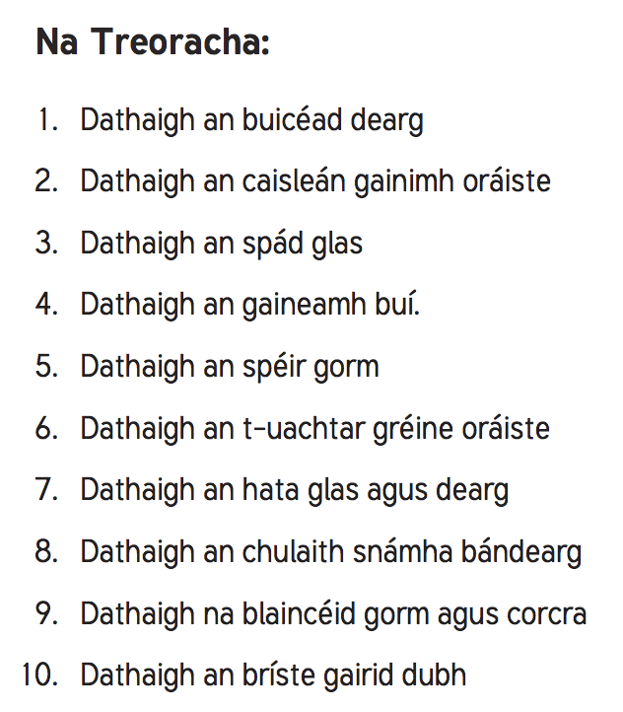
PE: On Youtube, Joe Wicks is doing a new PE workout each day for children at home called P.E. with Joe. Now he is starting to do less videos but pick your favourite ones and stay active. Follow the workouts on your TV, computer or tablet.
https://www.youtube.com/channel/UCAxW1XT0iEJo0TYlRfn6rYQ

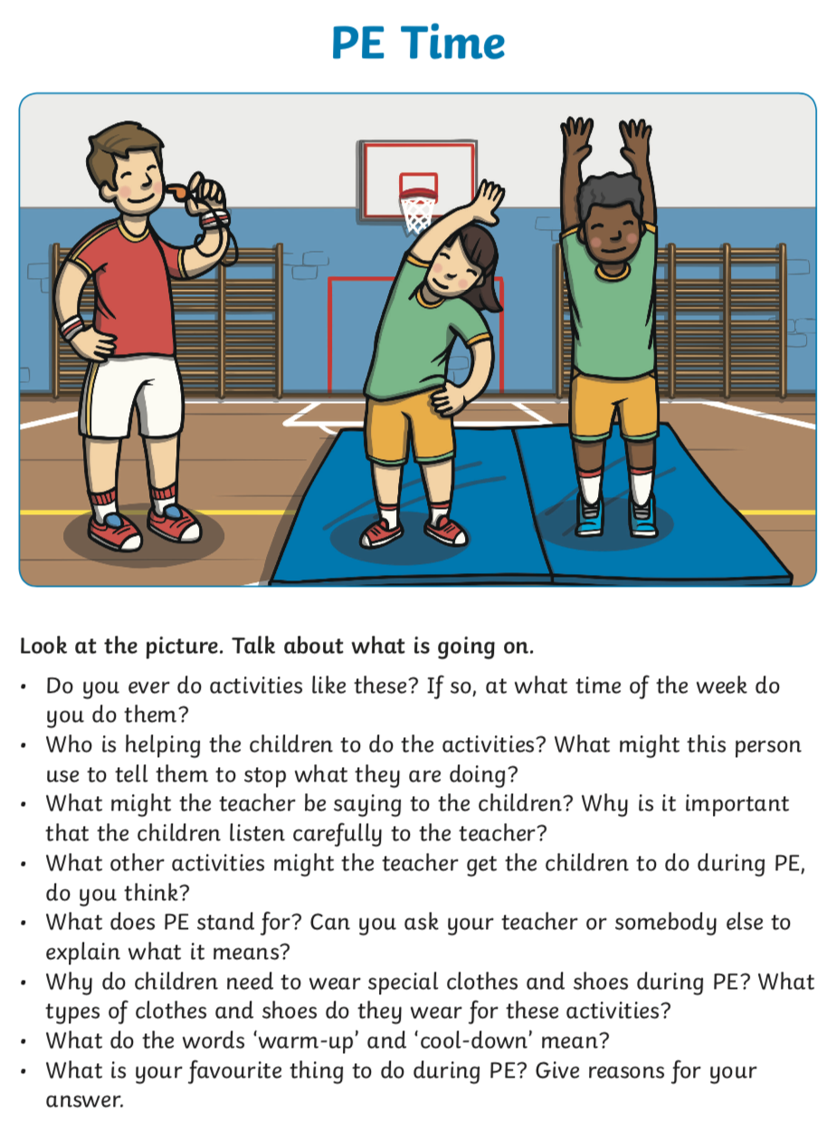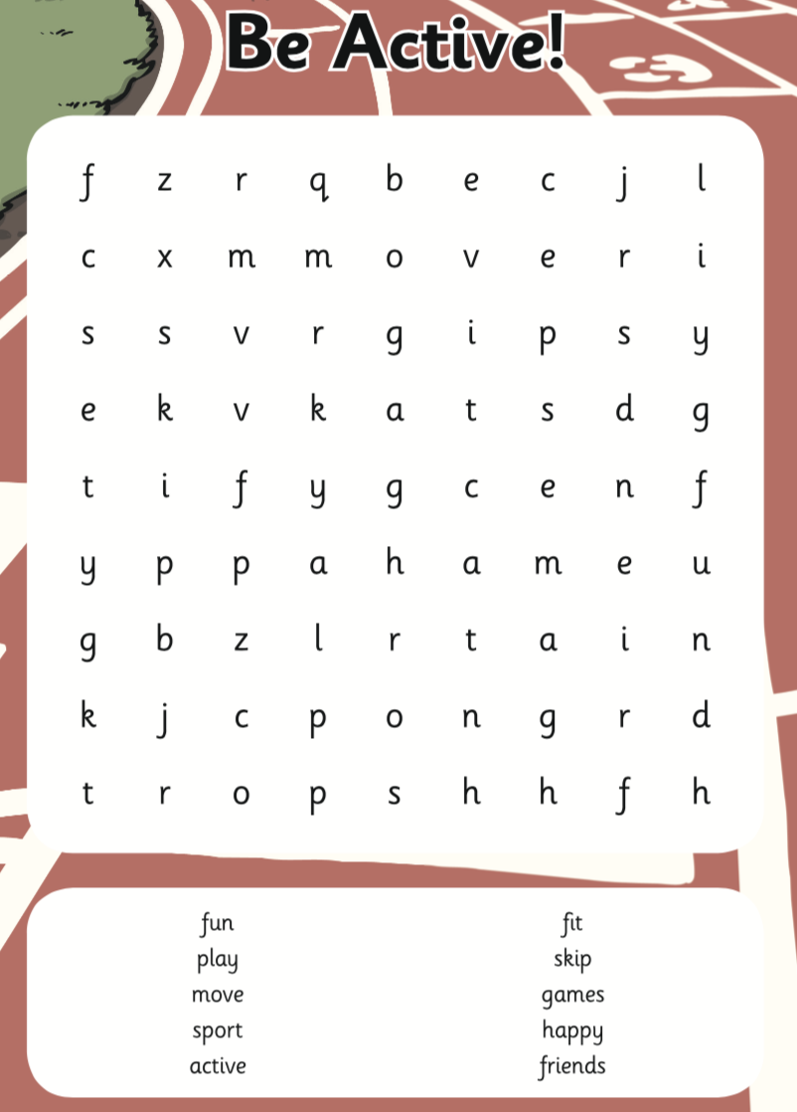
Religion:
To help teachers, students and parents during this difficult time Grow in Love granting free access to Grow In Love AND Soul seekers online series. Simply login on the www.growinlove.ie website with the following details:
Email: trial@growinlove.ie
Password: growinlove
‘Growing in love’ - https://app.growinlove.ie/en/user/lesson-resources/162

SESE: Try bake some delicious cookies
See if you can see the animals at Dublin Zoo through these live webcams. Be patient, the animals might be sleeping.

https://www.dublinzoo.ie/animals/animal-webcams/

Music
Learn the words and actions to this lovely song: Skidamarink a Dink a Dink
https://www.youtube.com/watch?v=6916kVhbEZw

Lyrics (x3)
Skidamarink a dink, a dink  Skidamarink a do  I Love You | Skidamarink a dink, a dink  Skidamarink a do  I Love You | I Love You in the Morning and in the Afternoon  I Love You in the Evening and Underneath the Moon oh

SPHE:
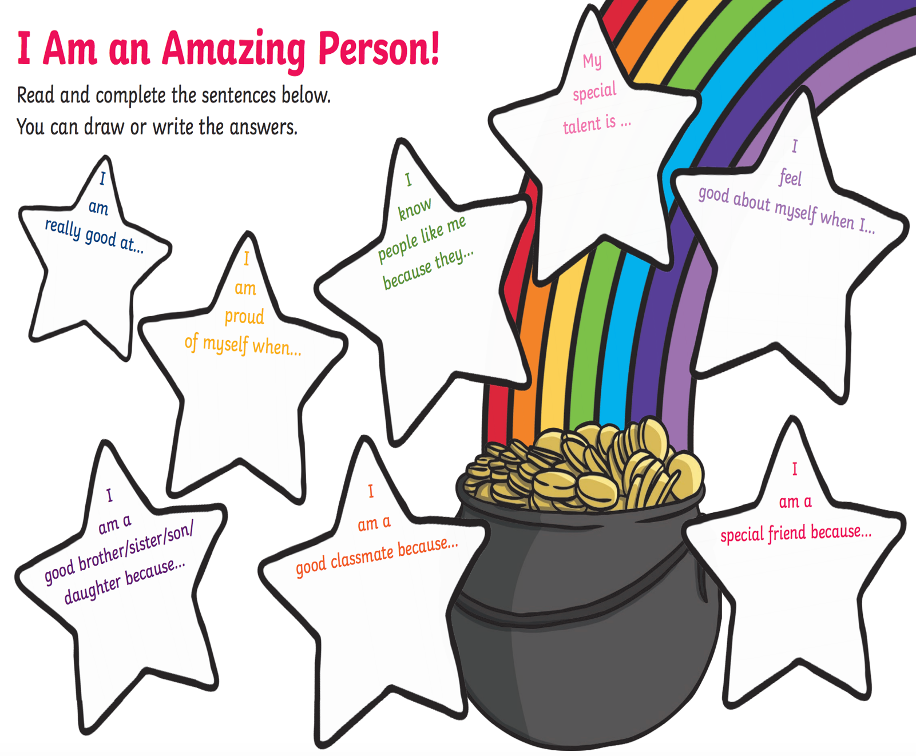

Art:
Have a try at the following tutorials.
https://www.youtube.com/watch?v=CmSm7y_hvyc

https://www.youtube.com/watch?v=laVebaRmKdA

Thank you for your patience at this difficult time and we really appreciate all the hard work you did over the last few months. We hope everyone has a safe, happy and wonderful summer break.

Ms Boyle & Mr Doody

First Class Boys Graduation Mass
Please practice these words as much as possible before Tuesday’s Graduation.
Also, have ONE thing you loved about Marist National School prepared to say at the Graduation.
Song: Circle of Friends
Link: https://www.youtube.com/watch?time_continue=3&v=cCN1W_Re34s&feature=emb_logo
Lyrics:
You have friends, you are not alone.
Thanks to them, you're not on your own.
You are strong, even when you feel small.
From the rain, they will shelter you.
In your pain, they will comfort you.
They will always pick you up when you fall.

Chorus:
Circle of friends, all around you.
Circle of friends, strong and true.
Circle of friends, always there for you

Even when, you are far apart.
To your friends, you're joined heart to heart.
Far away, you are not on your own.
You're not there, but they think of you.
In their prayers, they remember you.
You are never ever truly alone.

Poem:
Remember
Remember when we came to school,
And sat upon a tiny stool.
And all the other kids were tall
And we were very, very small.
Remember!

Remember how we learned to play,
To read and write, to draw and pray,
And all the things we learned to do
And how we grew and grew and grew.
Remember!

