Suggested Weekly Work for 5th class – 8/6/’20 - 12/6/’20
A note from teacher:
Hello girls,
I hope you are all well? We had good news on Friday about the early lifting of some restrictions. I’m sure everyone is delighted to see things coming back to “normal”. However girls, it is very important to remember that we must still keep our social distance and we must do everything we can to ensure that we are keeping ourselves and those around us safe. If we all play our part, we will reap the rewards in the weeks and months to come!
The weeks are flying by girls! You are all doing really well with the work you are doing! Well done, I am so proud of you all! From now on the workload will get lighter each week. I have given you a new list of work for this week with lots of fun activities for you to do at home! Let me know how you get on! Remember you can email me at fifthclassmarist@gmail.com
Have a great week girls,
Keep safe everyone,
Ms. Tiernan

English
Reading:

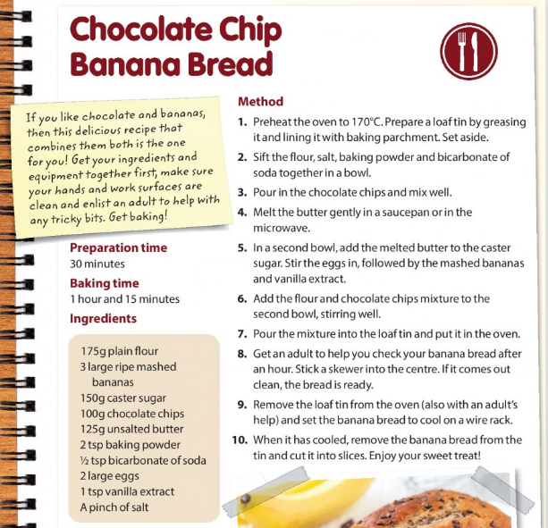
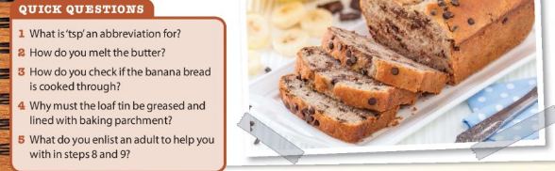

Comprehension:
This week we are again focusing on Poetry. Here I have included the poem “My Shadow” by Robert Louis Stevenson. Read the poem a number of times to familiarise yourself with it and then answer the questions. Do you know of any other poems written by this poet? Tell me about them.

My Shadow
BY ROBERT LOUIS STEVENSON
I have a little shadow that goes in and out with me,
And what can be the use of him is more than I can see.
He is very, very like me from the heels up to the head;
And I see him jump before me, when I jump into my bed.

The funniest thing about him is the way he likes to grow—
Not at all like proper children, which is always very slow;
For he sometimes shoots up taller like an india-rubber ball,
And he sometimes gets so little that there's none of him at all.

He hasn't got a notion of how children ought to play,
And can only make a fool of me in every sort of way.
He stays so close beside me, he's a coward you can see;
I'd think shame to stick to nursie as that shadow sticks to me!

One morning, very early, before the sun was up,
I rose and found the shining dew on every buttercup;
But my lazy little shadow, like an arrant sleepy-head,
Had stayed at home behind me and was fast asleep in bed.

Questions:
- Who is “he” in the poem?
- How does the narrator describe how children grow?
- Why is the way the shadow grows “not at all like proper children”?
- What do you think the word “notion” means on line 9?
- Use the text to help you explain what a coward is. How do you know?
- Who does the narrator mean when using the word “nursie”?
- Does the language in the poem indicate that this is an old or modern poem? Give three examples to back up your answer.
- In the final verse, Which line gives the scientific reason as to why the narrator can’t see their shadow when they go outside? Explain your choice.

Grammar: Metaphors
A metaphor is a figure of speech that is used to make a comparison between two things that aren’t alike but do have something in common.
A metaphor isn’t a comparison- that’s a simile!
Examples of a metaphor are:
- The snow is a white blanket.
- She is a shining star.
- Life is a rollercoaster.
- Your brain is a computer.

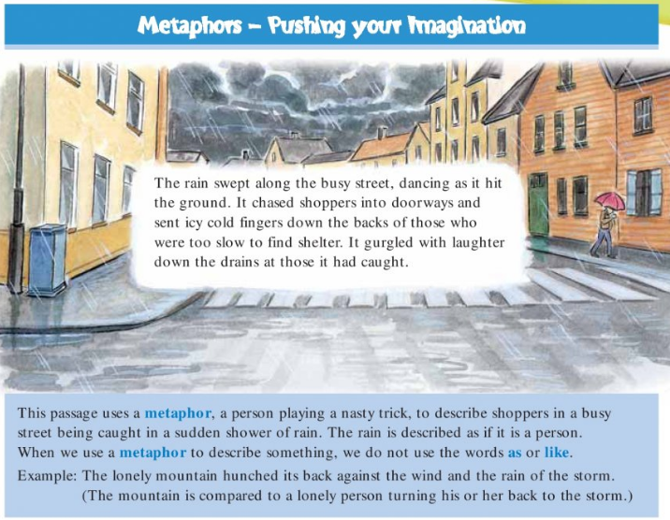
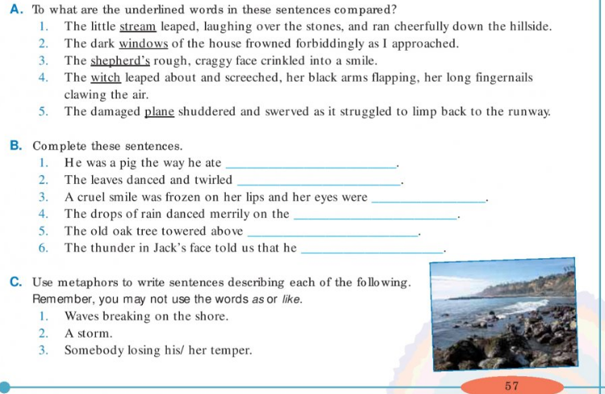

Gaeilge:
Abair Liom: An Aimsir: lch 142 agus 143
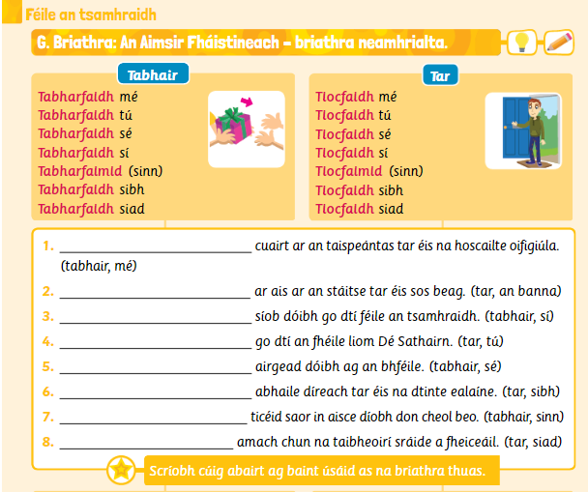
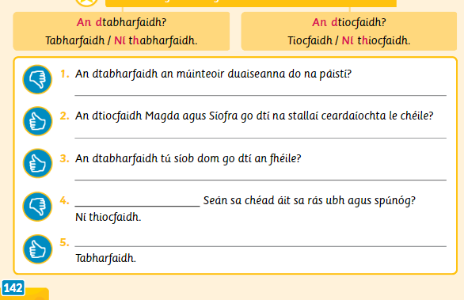
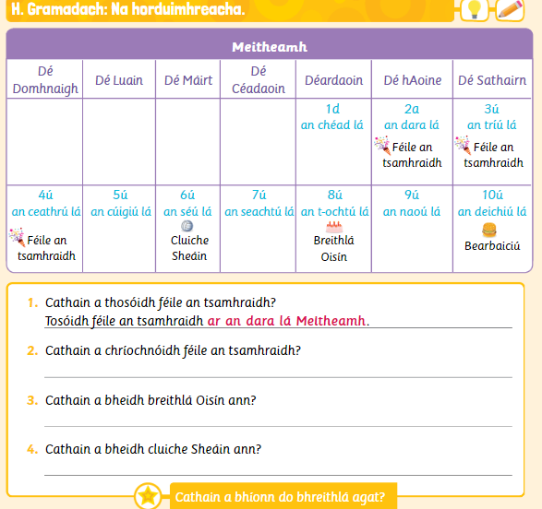
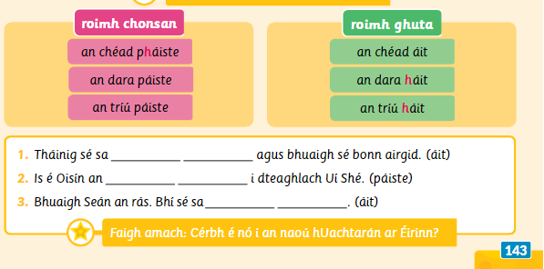

https://www.folensonline.ie/home/library/programmes/abair-liom-5th-class/ebook/
Duo lingo Gaeilge – a fun way to learn Irish online https://www.duolingo.com/learn
Fóclóir/Vocabulary:

tabhair- to give | duais- prize | in aisce dίobh- free of charge
tar- to come | stallaί ceardaίochta- craft stalls | dίreach abhaile- straight home
taispeaántas- exhibition | orduimhreacha- ordinal numbers | bonn airgid- silver medal

Maths:

- Mathletics to be done at home – [If you have lost your login details, please let me know and these can be forwarded to you directly]

Busy at Maths 5 Chapter 22: Percentages 2 pg 120, 121 and 122
Strand: Number
Strand Unit: Decimals an Percentages
- To convert decimals to percentages, multiply by 100 e.g. 0.23 x 100= 23%
- To convert percentages to decimals, divide by 100 e.g. 99% ÷100 = 0.99
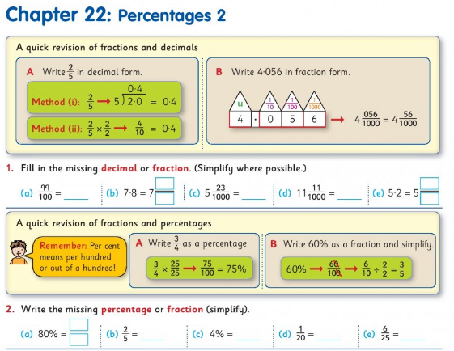
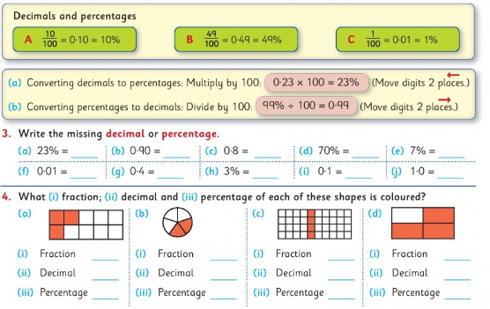
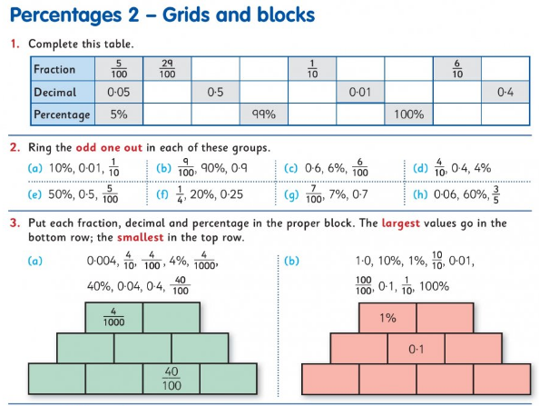
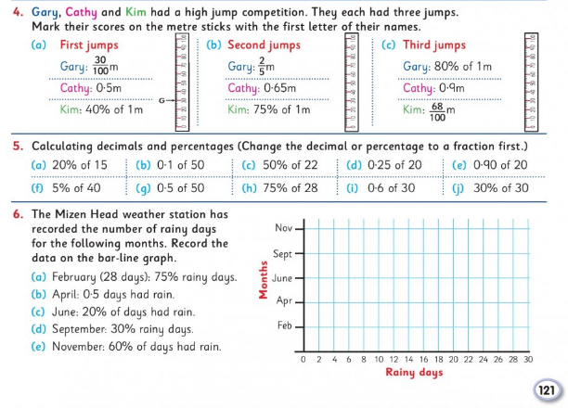
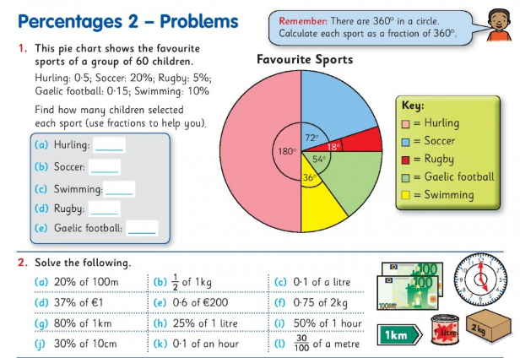
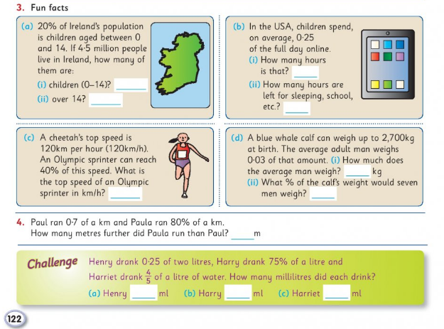

Maths Challenge for the whole family!
Bothersome Brainteasers!
- Suppose you want to cook an egg for exactly three minutes. You have only got a five-minute hour glass timer and a two-minute hour glass timer. Using these two timers, how can you boil the egg for exactly three minutes?

- In the basement there are three light switches in the “off” position. Each switch controls one of three light bulbs on the floor above. You may move any of the switches, but may only go upstairs one time. How can you determine which switch controls each light?

SPHE: Give this Star Breathing activity ago- it is nice and relaxing!
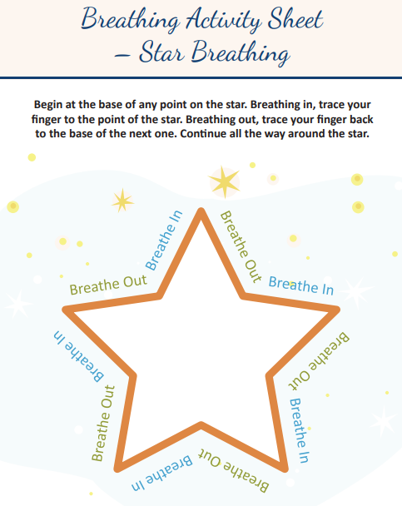
SESE:
Science:
This week we will be learning all about sound. We are going to investigate sound as a form of energy.
To complete this investigation you will need:
- A bowl
- Cling film
- Rice
Wrap cling film lightly around the rim of the bowl ( it may be necessary to use sellotape to keep the cling film in place)
Next, place a few grains of rice on top of the cling film.
Now you must place various sources of sound near the bowl, one at a time, and observe the rice closely.
- What sources of sound can you use? E.g. saucepan lid and wooden spoon, speaker, television.
- What do you notice? What does this mean?
- Does the source of sound make a difference to the rice?
- Does the volume affect the rice?
- Does the distance from the rice to the source of the sound affect the result?
- How can you record your results?
- Can you think of any other ways to see sound?

STEM Challenge- Design and make a musical instrument

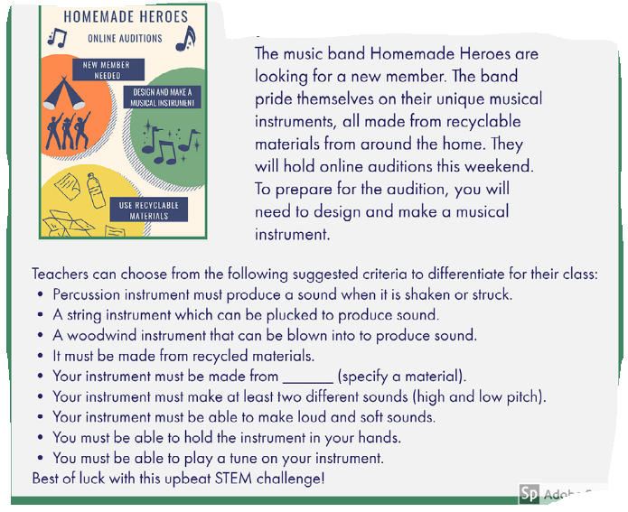
PE:
Play Monopoly with a difference!!
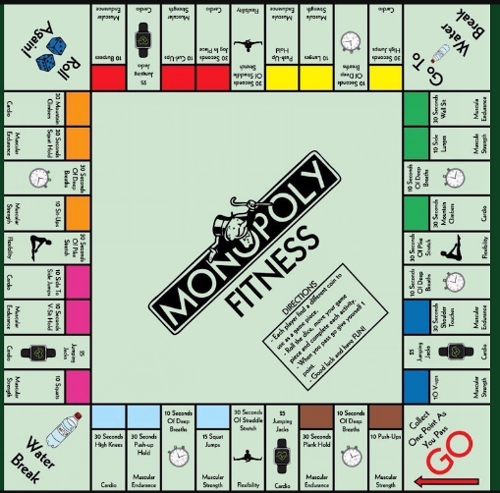

Religion:
To help teachers, students and parents during this difficult time Grow in Love granting free access to Grow In Love AND Soul seekers online series. Simply login on the www.growinlove.ie website with the following details:
Email: trial@growinlove.ie
Password: growinlove
https://app.growinlove.ie/en/user/theme-lessons/138
This week we are looking at Theme 10: The Mass.
Lesson Two: The Table of the Lord

Music
Clink on the link on the fifth class page on our website to see the music lesson Ms. Barry has created for you this week.

Art
I loved the drawings you sent me last week. They were absolutely amazing!
Click on the link below and follow the steps to help you draw some animals.
https://www.youtube.com/watch?v=7SWvlUd2at8&t=13s

Family Fun
Normally in the month of June we would be doing lots of fun activities like Sports Day, School Tours etc. This year I am sending you on “Virtual School Tours”. Click on the link below and take a tour around Áras an Uachtaráin- the home of President Michael D. Higgins .
Áras an Uachtaráin: https://president.ie/en/explore-visit/interactive-tour
Later in the week, go on a virtual trip to Paris and visit Le Louvre. See can you find the famous Mona Lisa
Le Louvre: https://www.louvre.fr/en/visites-en-ligne

Escape Rooms
Here are two fun activities that you can do with your whole family. Start with Goldilocks and the Three Bears and then take a trip to Hogwarts and try to solve that puzzle!
Goldilocks and the Three Bears
https://docs.google.com/forms/d/e/1FAIpQLSe1xF-PUPOxGO0loMSoBkwXeHQUPsep9_EwWA7SP9YwaIs3Lg/formResponse

Harry Potter
https://docs.google.com/forms/d/e/1FAIpQLSflNxNM0jzbZJjUqOcXkwhGTfii4CM_CA3kCxImbY8c3AABEA/viewform?fbclid=IwAR3wMMa5PwPM_eoXaDVipqrwSC194-eVq3m5oleIbo_wJapQRMLoI59VHdQ

Our thought for the week this week is:
“Today was good. Today was fun. Tomorrow is another one”
-Dr. Seuss-
Remember girls you can email me with your work or questions and I will get back to you as soon as I can.
fifthclassmarist@gmail.com
Have a great week!
Ms. Tiernan

