**Spooky Jelly October 2024**

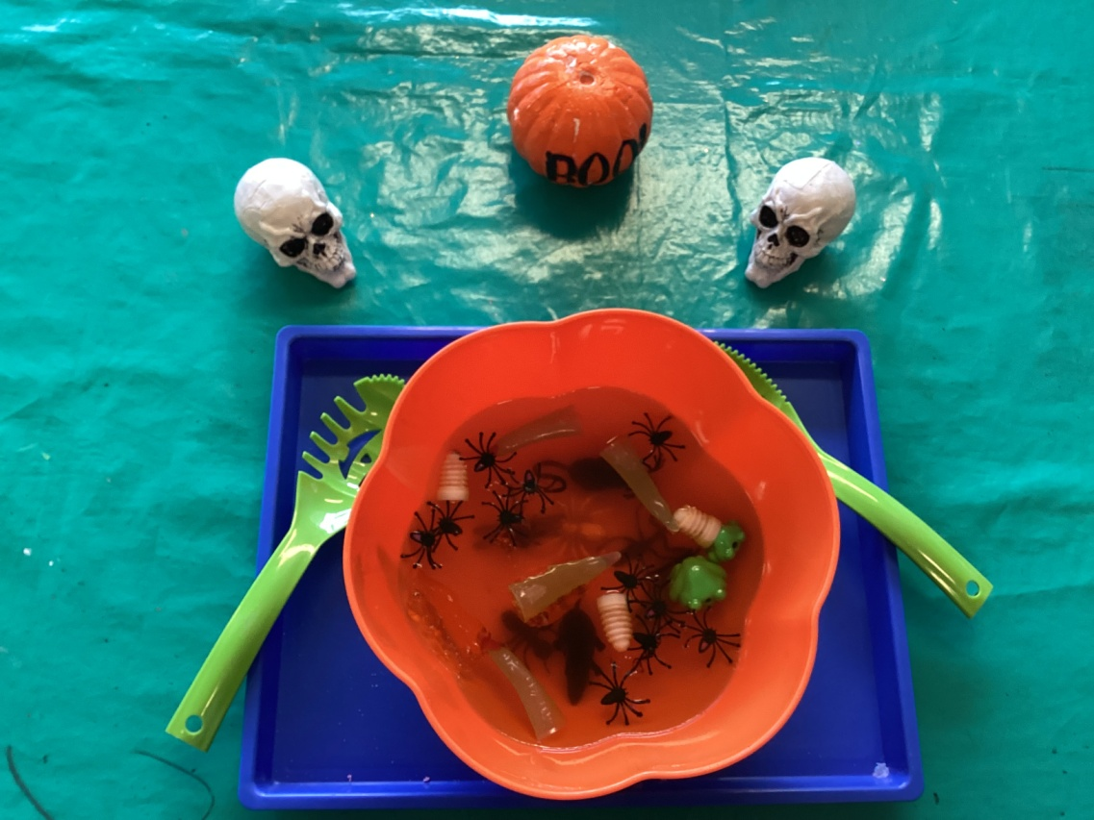

Vocabulary

**Smells like… orange, cupcakes, jelly, stinky dead bugs.**

**Feels like… washing in it like soap, slimy, cold, good, sticky, stuck, disgusting**

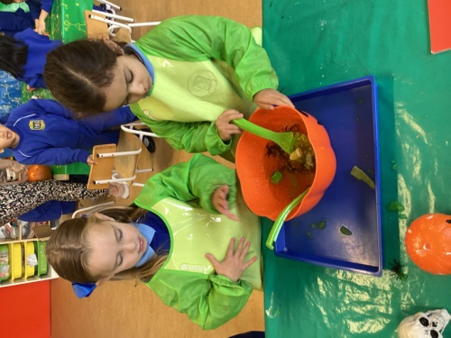

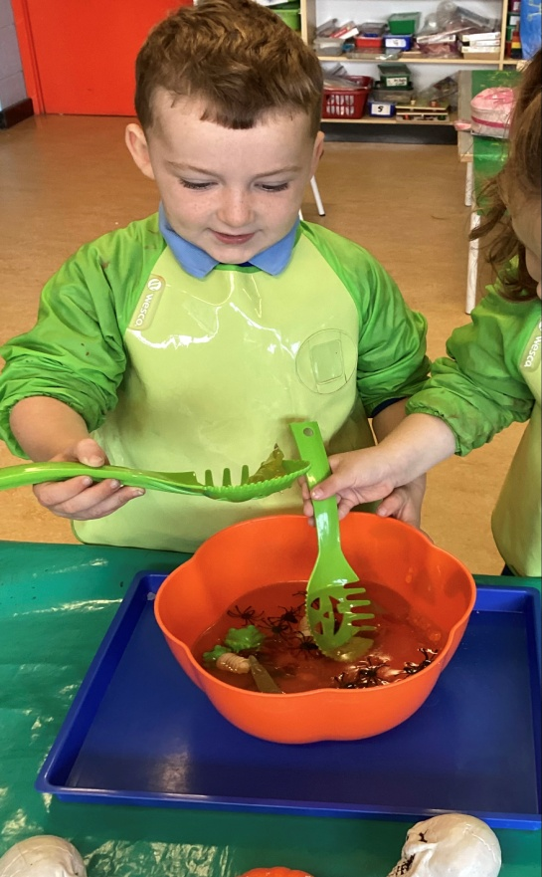 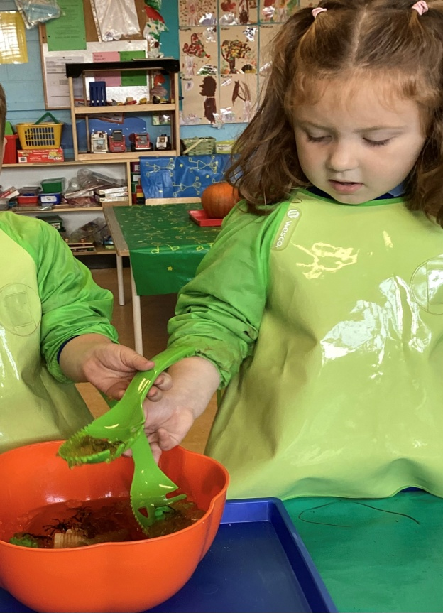

**Spooky Jelly 23/10/24 Spooky Jelly 23/10/24**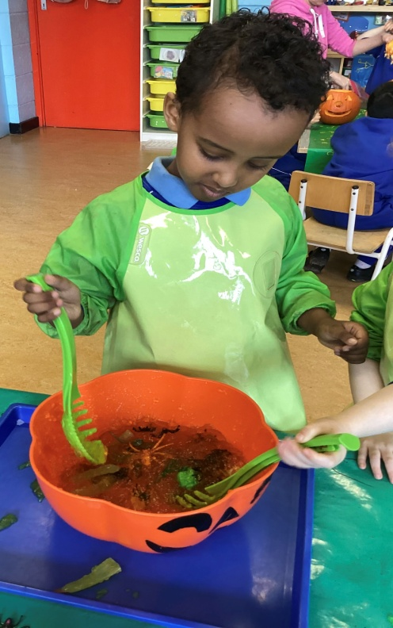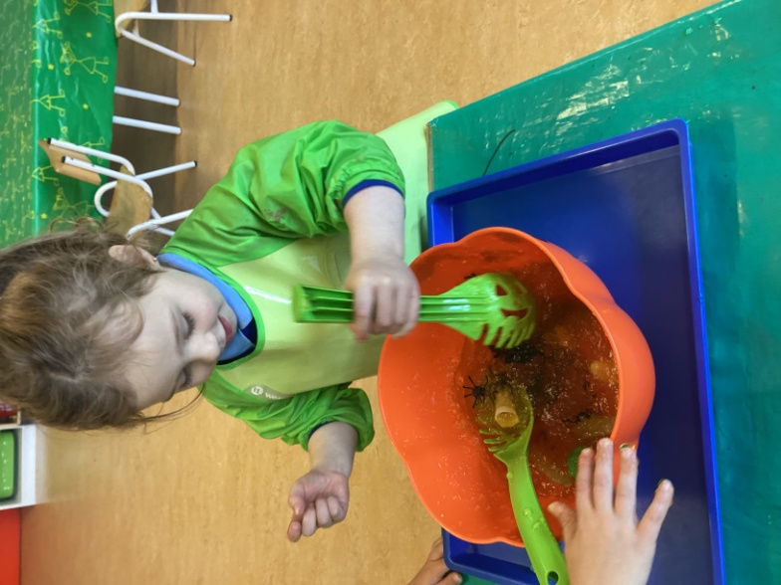

**Spooky Jelly 23/10/24 Spooky Jelly 23/10/24**

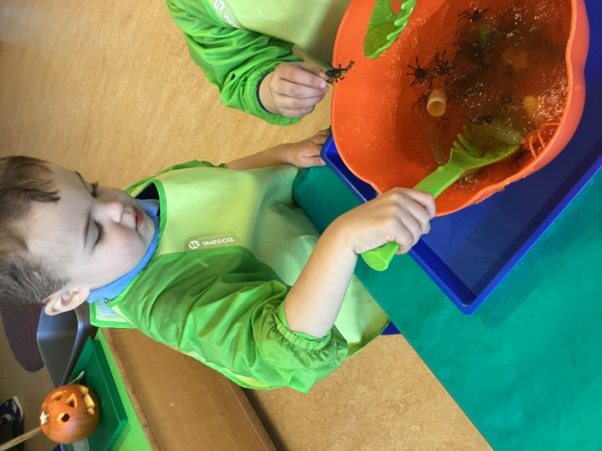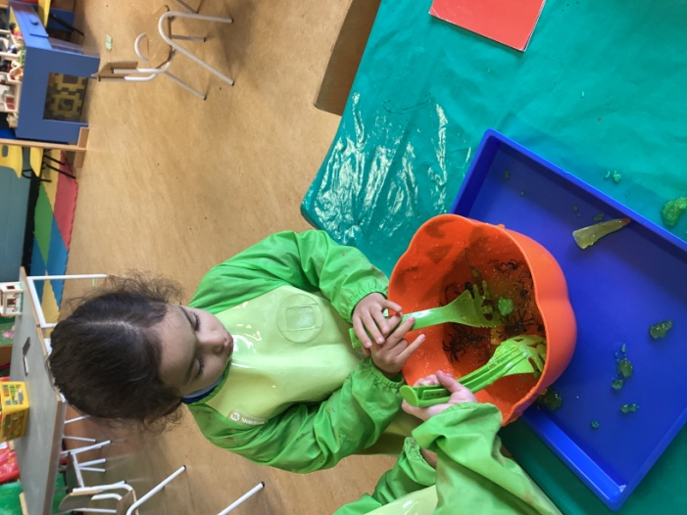

**Spooky Jelly 23/10/24 Spooky Jelly 23/10/24**

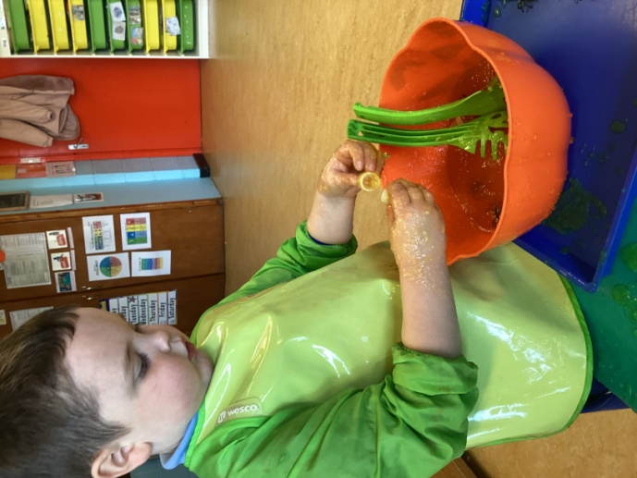 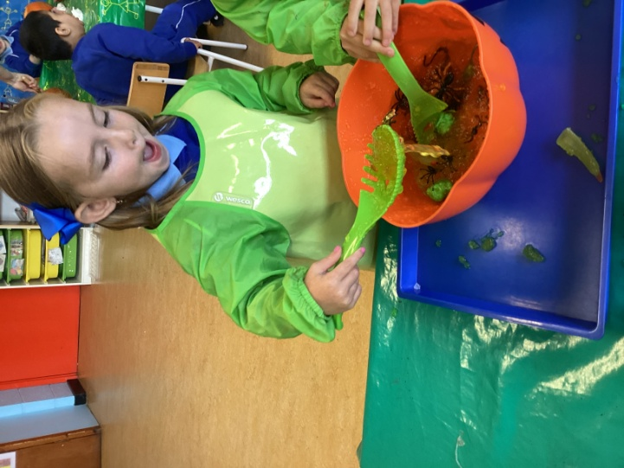

**Spooky Jelly 23/10/24 Spooky Jelly 23/10/24**

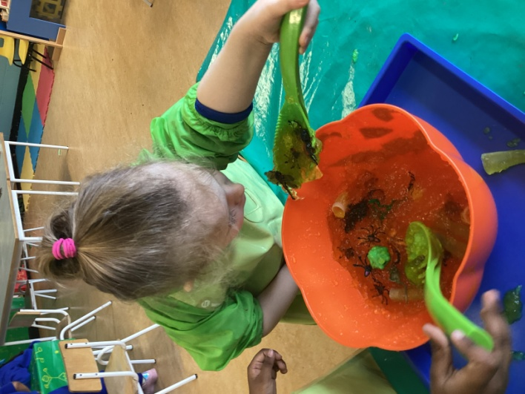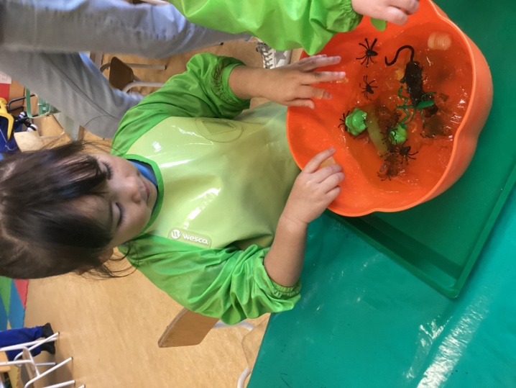

**Spooky Jelly 23/10/24 Spooky Jelly 24/10/24**

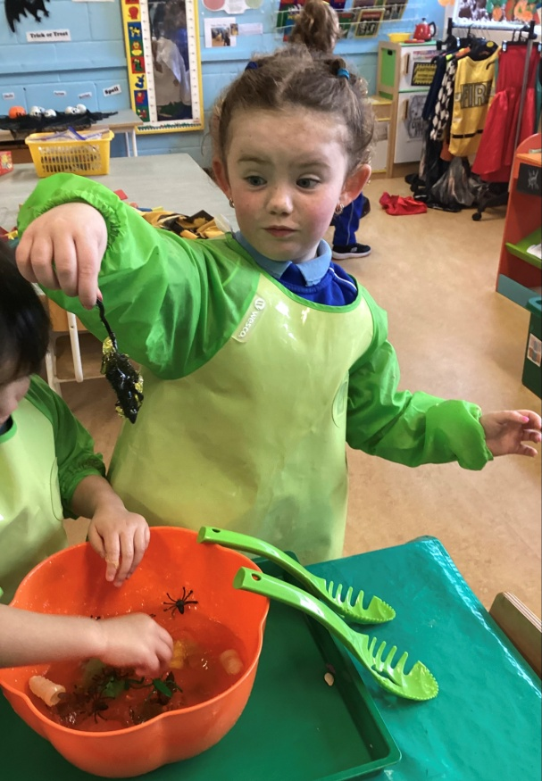 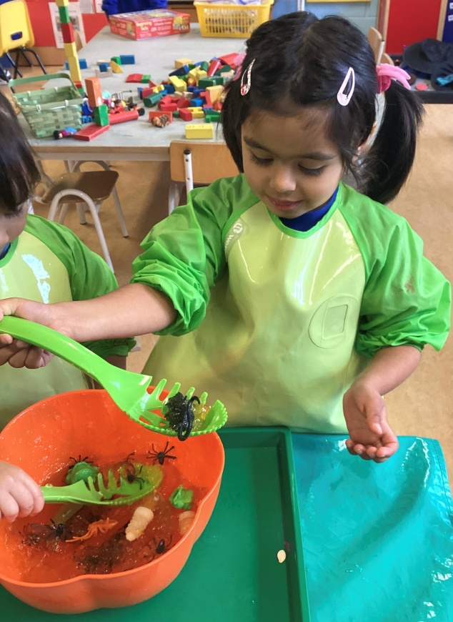

**Spooky Jelly 24/10/24 Spooky Jelly 24/10/24**

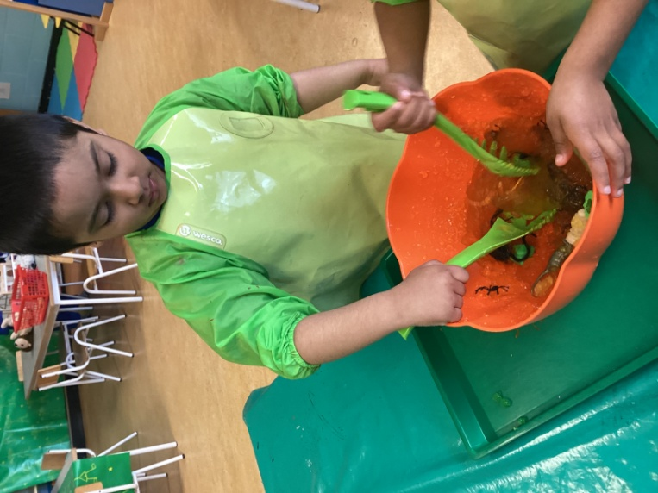 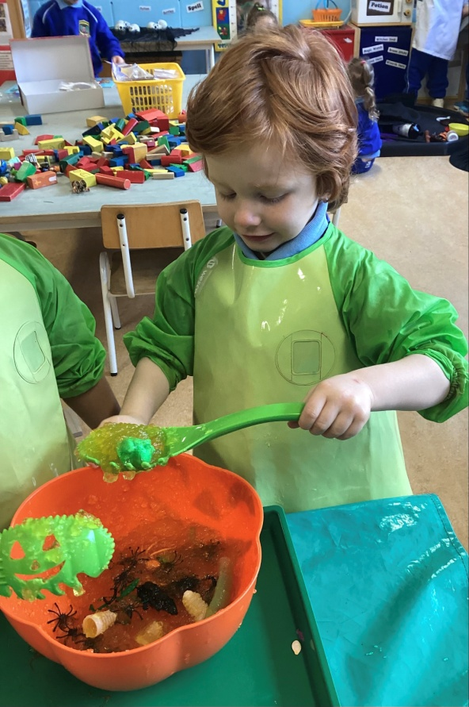

**Spooky Jelly 24/10/24 Spooky Jelly 24/10/24**

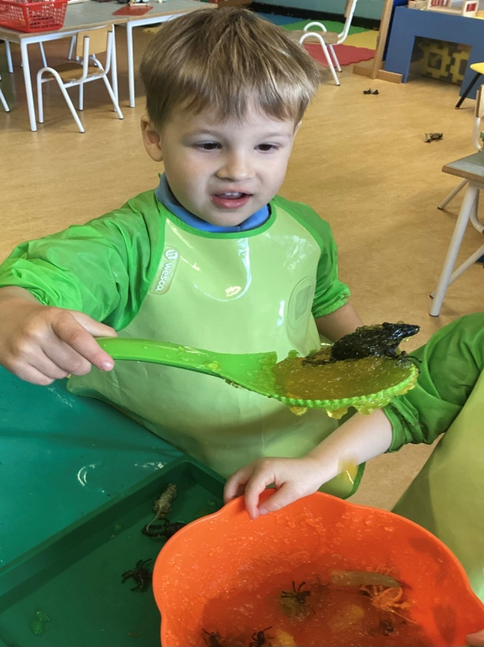

**Spooky Jelly 24/10/24**